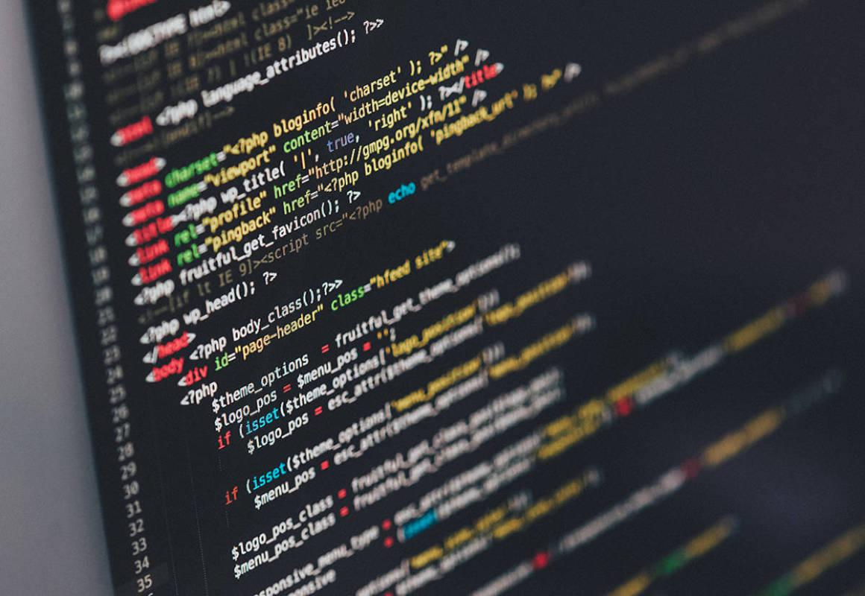

**CIS016-1 – Principles of Programming**

**Assignment 2 –** **Hotel Online Customer Booking and Management System**

**INDIVIDUAL REPORT**

**INDIVIDUAL WORK**

**Student ID: 2146513 Full Name: Prabin Kumar Labh**

Contents

Introduction/Overview 4

Task Description 4

Project Plan/Schedule 5w

Overview of Functional, Technical (Non-Functional Requirements) and Usability Requirements 6

Functional Requirements 6

Non-functional Requirements 7

Usability Requirements 7

Design 8

Uses Case Diagrams(s) 8

Activity Diagram(s) 10

Class Diagram(s) 12

Database Design 12

Entity Relationship Model (ERM) 12

ERM Diagram 12

List of Entities 13

Physical Database Design (including Data Dictionary) 14

Skeleton Tables 14

Data Dictionary (for each table) 14

Data Dictionary for Room 14

Data Dictionary for Customers 15

Data Dictionary for Receptionist 17

Data Dictionary for Booking 18

Data Dictionary for Invoice 20

User Interface Design 21

Implementation 25

Testing 32

TEST FOR LOGIN 32

TEST FOR REGISTRATION 36

TEST FOR BOOKING 37

TEST FOR ADMIN PAGE 39

Discussion / Refection / Critical Analysis 42

Conclusion 42

References 43

Appendix 44

# Introduction/Overview

The task of this assignment was to the investigating the brief provided for the online hotel booking system and implement a system that includes all the required specification of the brief. A client server application needs to be created for hotel booking application. The main task is to create a system that allows customer to register and create an account with their details. After the account is created customer needs to log in to book, view, change or cancel upcoming booking. Receptionist can assign room to the booking matching the customer’s demand. Receptionist needs to check whether the room is available for the time requested or not and for that she should have access to view existing bookings per room. Also, a database needs to be created to store data such as customer's information, booking information, room details and assigned room type to the bookings.

# Task Description

The requirement of this assignment is to create a GUI desktop application to meet the requirement of this scenario. Also, a database is required to store customers information booking information as well as room information. Main user roles are non-corporate, corporate organization receptionist and bar/restaurant staffs each of the users have different login page.

Hotel Luton is a large independently run hotel which offers variety of accommodation like

* Rooms with facilities like telephone and minibar.
* Bar and restaurant for refreshments.
* Room services are also available and other services that guest require can be order by them through the hotel receptionist.
* All these charges will be added to their bills and needs to be paid before making a check out.

The hotel provides an online service for customers. Customers are divided into two categories that is non-corporate (individual) and corporate and each of them are provided with different facilities. Non corporate customers must first login by providing address, phone number, e-mail, and credit card information. A registered customer can make booking, view booking, change or even cancel booking if they have not checked in yet. Customers can provide room type that they require, and all this can be done only after they login. Corporate customer needs to set-up an account with the hotel before making a corporate booking and all these are billed at the end of each month for those booking that have been completed since the last invoice was sent. Discount is also provided to the corporate client after the accounts are set-up and is reviewed every year.

A database is required for storing all the data like

* Non corporate/corporate clients (name, address, phone, email, card detail etc.)
* Booking (check in, check out date and room type)
* Room (single, double, and twin)

After a booking request is made by customer first the receptionist checks whether the requested rooms are available for the time requested or not then the room are assigned to each booking as per customers request for the room type, check in and check out date. Each booking is assigned with only one room. For corporate clients the booking is guaranteed after the receptionist assign room and approves the booking. For non-corporate clients credit card detail is mandatory for guaranteed booking if the card details are not given then the booking will be considered as unguaranteed. The guest can check in whenever they want after the booking is guaranteed. Guests can cancel booking anytime if guests have not checked in.

The booking will be active when guests check in and the booking end once the guest check-out. Non corporate customer they first pay their bill and once becomes paid then they can check out. While for corporate clients they can do check out and the bill will be paid when they receive the monthly invoice. Bookings that are paid or cancel or archived are kept on system for six months.

# Project Plan/Schedule

|  |  |  |
| --- | --- | --- |
| Week No. | Tasks | Priority |
| Week 1 | Work on introduction and overview | MUST |
| Week 2 | Completing requirements | MUST |
| Week 3 | Database design and prototype | MUST |
| Week 4 | GUI designing | MUST |
| Week 5 | Desktop application and logical programming | MUST |
| Week 6 | Report writing | MUST |
| Week 7 | Project preparation | MUST |
| Week 8 | Submit Report, Project Code, and Individual Reflective Report, Video Recording | MUST |
| Week 9 | Project Presentation | MUST |

# Overview of Functional, Technical (Non-Functional Requirements) and Usability Requirements

## Functional Requirements

* As customers must be able to register and log in to the online booking system.
* A customers must be able to view all bookings made in past.
* A customers must be able to make, view and cancel booking.
* Customers can make multiple booking using same id.
* A customer must be able to get all extra facilities which are not provided by hotel.
* After logging in customer should be able to see the booking made and the status of booking.
* A receptionist must be able log in to the system.
* Receptionist needs to first check available room for requested period then assign room to booking requested.
* A receptionist must be able to search and see available rooms.
* A receptionist must be able to view all booking and approve bookings.
* All bills are added to the room bill.
* Receptionist must be able to generate total bill while checkout.
* User should be able to view all the bills and their total in their user profile.
* At the time of checking out all bills should be paid by non-corporate customers.
* Corporate customer will be billed at the end of every month.

## Non-functional Requirements

* The system should de desktop adaptive and platform independent.
* The system design should be sufficiently scalable and flexible so that it can be upgraded in future.

## Usability Requirements

* User friendly system
* Required information about their booking should be provided to meet user’s need
* Entry validation should be present and entry forms should be short and easy to complete
* The system application should have clear and intuitive navigation.
* Layout and style should be consistent throughout the application.

# Design

## Uses Case Diagrams(s)

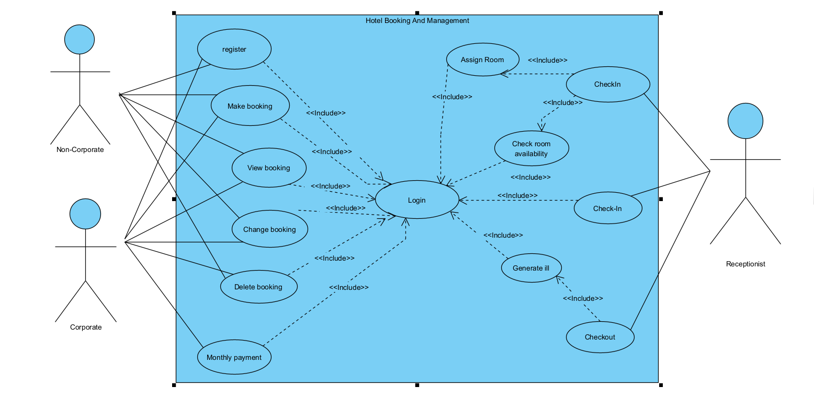

Figure 1: Hotel Online Customer Booking and Management System - Use Case Diagram (Sea Level)

Alyssa Walker.,2022. (Walker, 2022)

**“Use Case Diagram** captures the system’s functionality and requirements by using actors and use cases. Use Cases model the services, tasks, function that a system needs to perform. Use cases represent high-level functionalities and how a user will handle the system. Use-cases are the core concepts of Unified Modelling language modeling.”

The use case diagram shown in above figure that demonstrates the core functionality of the system. Here we can see manly three actor’s receptionist, corporate customer, and non-corporate customer. This picture also shows that to make or change booking customers needs to log in and same goes for receptionist to approve and assign she also needs to login. The use case diagram shows that customer making a reservation is dependent on the server checking the availability of rooms and this is important for system to check whether there is room available to assign to the booking requested.

Use Case Specifications/Description

Allocate Accommodation

A specific room is allocated to each guest.

Change Booking

An unguaranteed booking may become guaranteed on provision of credit card details. Other changes (for example to the composition of the party or to the dates booked) may be made on the customer’s request.

Calculate Bill Total

The total bill for a room comprises the cost of the room plus any items charged to it plus the appropriate rate of VAT.

Cancel Booking

A customer may cancel a booking any time before checking in. The booked accommodation is de-allocated.

Check In Guest

When a party (one or more guests) arrives at the hotel each guest is checked in and the booking becomes registered. Details of all the guests are confirmed, or if they have not been given at the time of booking they are recorded. The method of payment (by which guest(s) or whether to be charged to a corporate account) is confirmed. Accommodation is allocated if not already done at the time of booking and special requests are recorded.

Check Out Guest

Before the guest leaves the hotel they need to check out and the booking becomes completed. The receptionist provides them with the total room bill, which an individual customer must pay. If the bill is to be charged to a corporate customer the guest is asked to check and sign the bill, it is then added to the appropriate corporate account.

Make a Booking

When a customer contacts the receptionist with a booking request the receptionist checks the room occupancy for the required period and if the customer's needs can be met, makes a booking.

A guaranteed booking is only made for corporate customers or for individual customers who supply credit card details.

Accommodation may be allocated at this stage; alternatively, where it is a group booking (for example, for 6 twin-bedded rooms) the allocation of each guest in the party to a specific room may be done on checking in. Either way, occupancy records are updated to avoid double booking.

Services not offered by the hotel itself can be ordered, once their availability has been checked. The guest name, room number and details of the service required are taken when the service is ordered.

Provide Guest with Current Bill

On request a guest may be provided with the current total of their bill.

## Activity Diagram(s)

Activity diagram is basically a flowchart to represent the flow from one activity to another activity. The activity can be described as an operation of the system.

The control flow is drawn from one operation to another. This flow can be sequential, branched, or concurrent. Activity diagrams deal with all type of flow control by using different elements such as fork, join, etc. (tutorialspoint, 2022)

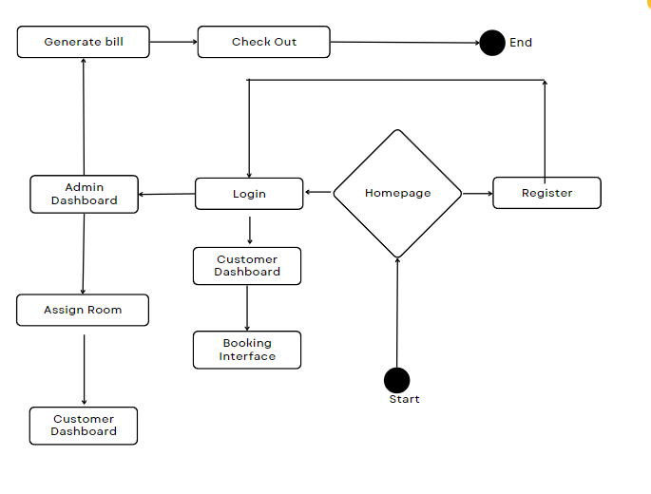

Figure 2 Activity Diagram

Above given shows the active activity diagram for this booking system. First interface that customer sees is the home page, from homepage customer can either login if registered already or register by providing their details. After login customer will see a customer interface where customer can request booking by providing check-in , check-out date an d preferred room type.

Receptionist can also login and after logging-in receptionist can assign room and confirm booking requested by customers. Receptionist can generate total bill and can check-in guest and checkout and receive payments.

## Class Diagram(s)

(JavaTpoint, 2011-2021)The class diagram depicts a static view of an application. It represents the types of objects residing in the system and the relationships between them. main purpose of class diagrams is to build a static view of an application. It is the only diagram that is widely used for construction, and it can be mapped with object-oriented languages. It is one of the most popular UML diagrams.

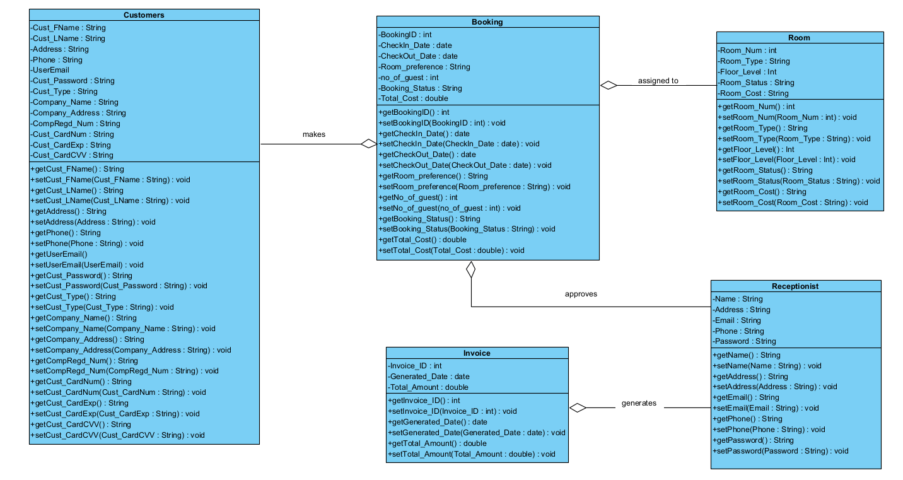

Figure 3 Class Diagram Hotel Booking System

# Database Design

## Entity Relationship Model (ERM)

### ERM Diagram

(Song & Chen, 2009), “The entity relationship model (ERM) is a conceptual model that represents the information structure of a problem domain in terms of entities and relationships. The result of modelling using the ERM is graphically represented as an entity relationship diagram (ERD).”

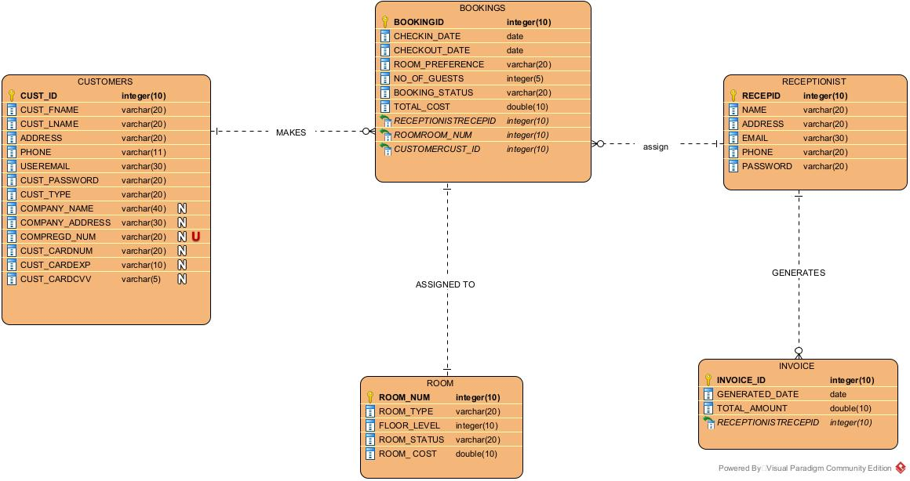

Figure 4 Entity Relationship Model For Hotel Booking System

To make ERD following entities are created for hotel booking system i.e., Customer, Booking, Receptionist, Room, and Invoice. The relationship that was seen are

* Customer can make multiple booking while a booking can be made by customer.
* Receptionist can manage multiple booking and assign room to that booking as requested.
* Every booking should be assigned with one room and a room can be assigned in multiple booking if available.
* Both customer and Receptionist need to login before customer can make or change booking and receptionist can assign room and approve booking.

### List of Entities

1. ROOM (Room_Num, Room_Type, Floor_Level, Room_Status, Room_Cost)
2. RECEPTIONIST (RecepID, Name, Address, Email, Phone, Password)
3. CUSTOMER (Cust_ID,Cust_FName, Cust_LName, Address, Phone, Email, Cust_Password,Cust_Type, Company_Name, Company_Address, CompRegd_Num, Cust_CardNum, Cust_CardExp, Cust_CardCvv)
4. BOOKING (Booking_ID, RecepID*, Room_Num*, Cust_ID*, Checkin_Date, Checkout_Date, Room_Preference, No. Of Guests, Booking_Status, Total_Cost)
5. INVOICE (Invoice_ID, RecepID*, Total Amount, Generated Date)

# Physical Database Design (including Data Dictionary)

To create database MySQL was used

## Skeleton Tables

* ROOM (Room_Num, Room_Type, Floor_Level, Room_Status, Room_Cost)
* RECEPTIONIST (RecepID, Name, Address, Email, Phone, Password)
* CUSTOMER (Cust_ID,Cust_FName, Cust_LName, Address, Phone, Email, Cust_Password,Cust_Type, Company_Name, Company_Address, CompRegd_Num, Cust_CardNum, Cust_CardExp, Cust_CardCvv)
* BOOKING (Booking_ID, RecepID*, Room_Num*, Cust_ID*, Checkin_Date, Checkout_Date, Room_Preference, No. Of Guests, Booking_Status, Total_Cost)
* INVOICE (Invoice_ID, RecepID*, Total Amount, Generated Date)

## Data Dictionary (for each table)

### Data Dictionary for Room

|  |  |  |  |  |  |  |  |
| --- | --- | --- | --- | --- | --- | --- | --- |
| ROOM | | | | | | | |
| **Description: Room details** | | | | | | | |
| **Field Name** | **Datatype** | **Length** | **Index** | **Null** | **Default** | **Validation rule** | **Description** |
| Room_Num  (Primary) | integer (10) | 10 | PK | No |  |  | Uniquely identifies  Each room |
| Room_Type | varchar (20) | 20 |  | No |  | Single, Double, Twin | Type of room |
| Floor_Level | integer (10) | 10 |  | No |  |  | Floor level for room |
| Room_Status | varchar (20) | 20 |  | No |  | Available or not available | Status of room |
| Room_Cost | double (10) | 10 |  | No |  |  | Total cost of room |

Indexes

|  |  |  |  |  |
| --- | --- | --- | --- | --- |
| **Key name** | **Type** | **Unique** | **Column** | **Null** |
| PRIMARY | BTREE | Yes | Room_Num | No |

### Data Dictionary for Customers

|  |  |  |  |  |  |  |  |
| --- | --- | --- | --- | --- | --- | --- | --- |
| Customer | | | | | | | |
| **Description: Customer details** | | | | | | | |
| **Field Name** | **Datatype** | **Length** | **Index** | **Null** | **Default** | **Validation rule** | **Description** |
| Cust_ID  (Primary) | integer (10) | 10 | PK | No |  |  | Autoincremented Uniquely identifies every customer |
| Cust_FName | varchar (20) | 20 |  | No |  |  | First name of customer |
| Cust_LName | varchar (20) | 20 |  | No |  |  | Last name of customer |
| Address | varchar (20) | 20 |  | No |  |  | Address of customer |
| Phone | Varchar (11) | 11 |  | No |  |  | Customer contact number |
| Email | varchar (30) | 30 |  | No |  | Must be email format containing an @ and a ‘.’  Regex expression used | Email of customer |
| Cust_Password | varchar (20) | 20 |  | No |  | Must contain special character and number | Customer login password |
| Cust_Type | varchar (20) | 20 |  | No |  |  | Customer type corporate or non-corporate |
| Company_Name | varchar (40) | 40 |  | Yes |  |  | Name of company for corporate user |
| Company_Address | varchar (30) | 30 |  | Yes |  |  | Address where company is located |
| CompRegd_Num | varchar (20) | 20 |  | Yes |  |  | Registration number of company |
| Cust_CardNum | varchar (20) | 20 |  | Yes |  |  | Customer card number |
| Cust_CardExp | varchar (10) | 10 |  | Yes |  |  | Customer card expiry date |
| Cust_CardCvv | varchar (5) | 5 |  | Yes |  |  | Customer card 3-digit security number |

|  |  |  |  |  |
| --- | --- | --- | --- | --- |
| **Key name** | **Type** | **Unique** | **Column** | **Null** |
| PRIMARY | BTREE | Yes | Cust_ID | No |

### Data Dictionary for Receptionist

|  |  |  |  |  |  |  |  |
| --- | --- | --- | --- | --- | --- | --- | --- |
| RECEPTIONIST | | | | | | | |
| **Description: Receptionist details** | | | | | | | |
| **Field Name** | **Datatype** | **Length** | **Index** | **Null** | **Default** | **Validation rule** | **Description** |
| RecepID | integer (10) | 10 | PK | No |  |  | Uniquely identifies  Receptionist |
| Name | varchar (20) | 20 |  | No |  |  | Receptionist full name |
| Address | varchar (20) | 20 |  | No |  |  | Receptionist address |
| Email | varchar (30) | 30 |  | No |  | Must be email format containing an @ and a ‘.’  Regex expression used | Email of Receptionist |
| Phone | varchar (20) | 20 |  | No |  |  | Contact number of Reception |
| Password | varchar (20) | 20 |  | No |  | Must contain special character and number | Login password of  Receptionist |

Indexes

|  |  |  |  |  |
| --- | --- | --- | --- | --- |
| **Key name** | **Type** | **Unique** | **Column** | **Null** |
| PRIMARY | BTREE | Yes | RecepID | No |

### Data Dictionary for Booking

|  |  |  |  |  |  |  |  |
| --- | --- | --- | --- | --- | --- | --- | --- |
| BOOKING | | | | | | | |
| **Description: Booking details** | | | | | | | |
| **Field Name** | **Datatype** | **Length** | **Index** | **Null** | **Default** | **Validation rule** | **Description** |
| Booking ID | integer (10) | 10 | PK | No |  |  | Autoincremented Uniquely identifies every  booking |
| Checkin_Date | date |  |  | No |  | Should not be past date | Check-in date of Guests |
| Checkout_Date | date |  |  | No |  | Must be a date after check-in date | Check-out date of  Guests |
| Room_Preference | varchar (20) | 20 |  | No |  | Single, Double, Twin | Type of room |
| No Of Guest | Integer (5) | 5 |  | No |  |  | Total number of guests |
| Booking_Status | varchar (20) | 20 |  | No |  | Cancelled, Pending, Booked | Status of booking |
| Total_Cost | double (10) | 10 |  | No |  |  |  |
| RecepID | Integer (10) | 10 | FK | No |  |  | Unique id number of Receptionist |
| Room_Num | Integer (10) | 10 | FK | No |  |  | Uniquely identifies every  room in hotel |
| Cust_ID | Integer (10) | 10 | FK | No |  |  | Uniquely identifies every  customer |

Indexes

|  |  |  |  |  |
| --- | --- | --- | --- | --- |
| **Key name** | **Type** | **Unique** | **Column** | **Null** |
| PRIMARY | BTREE | Yes | Booking_ID | No |
| FOREIGN | BTREE | Yes | RecepID | No |
| FOREIGN | BTREE | Yes | Room_Num | No |
| FOREIGN | BTREE | Yes | Cust_ID | No |

### Data Dictionary for Invoice

|  |  |  |  |  |  |  |  |
| --- | --- | --- | --- | --- | --- | --- | --- |
| INVOICE | | | | | | | |
| **Description: Invoice details** | | | | | | | |
| **Field Name** | **Datatype** | **Length** | **Index** | **Null** | **Default** | **Validation rule** | **Description** |
| Invoice_ID | integer (10) | 10 | PK | No |  |  | Autoincremented Uniquely identifies every  invoice |
| Total Amount | double (10) | 10 |  | No |  |  | Total amount after checkout |
| Generated Date | date |  |  | No |  |  | Date when invoice is generated |
| RecepID | integer (10) | 10 | FK | No |  |  | Unique id number of Receptionist |

Indexes

|  |  |  |  |  |
| --- | --- | --- | --- | --- |
| **Key name** | **Type** | **Unique** | **Column** | **Null** |
| PRIMARY | BTREE | Yes | Invoice_ID | No |
| FOREIGN | BTREE | Yes | RecepID | No |

## User Interface Design

To create a prototype for this hotel online booking system Balsamiq Wireframes was used. Using balsamiq a prototype design was created that helped in creating a final GUI. This prototype is just a reference for creating main and final GUI. Some screenshots of prototype are shared below.

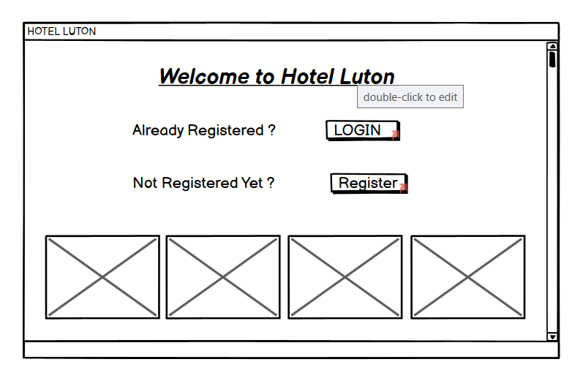

Figure 5 Homepage

This is the main page of hotel page from where customer can go to login or can register to create account.

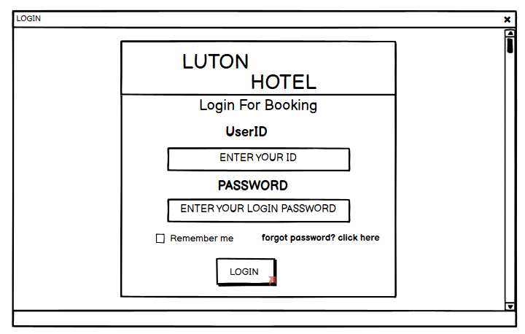

Figure 6 Login Page

This is the login interface which consist of hotel name and text field where customer can enter e-mail and password to log in. Once customer login he/she will be redirected to booking page where customer can make booking, edit booking, or delete booking. Also through this same page receptionist or admin can also login which will redirected to admin interface where receptionist can check available room and assign room to booking.

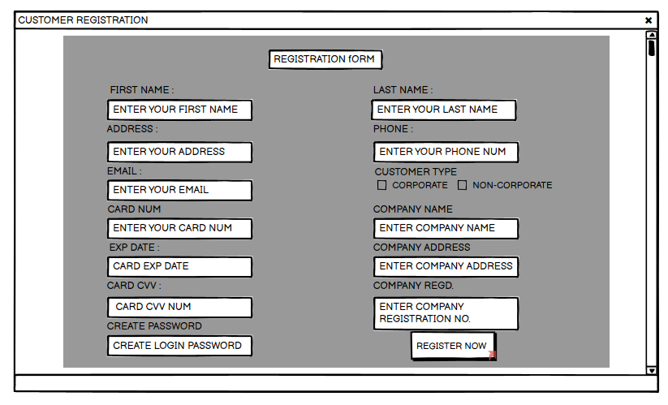

Figure 7 Registration Page

This is the registration page where new customers can enter their detail and register themselves so that hey can request booking for their holidays and event. Basically, two types of customers can register i.e., Corporate and Non-Corporate. Corporate customer needs to provide their basic detail along with their company detail like name registration number and address and for non-corporate customer it is mandatory to provide card detail. Once registered customer will be redirected to login page.

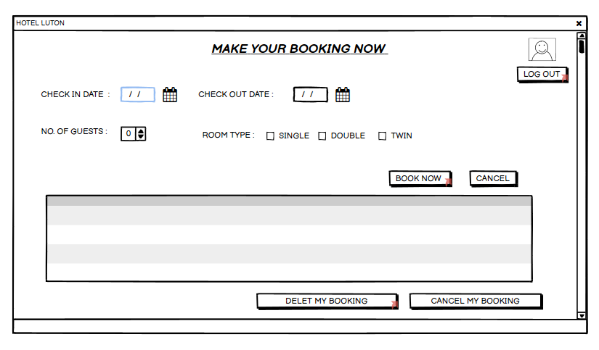

Figure 8 Booking Page

This one is the booking page which customer gets after login. After logging in customer can now request booking which will be approved by receptionist. Customer can provide check-in date, check-out date, number of guest and also, they can select the room type which they prefer.

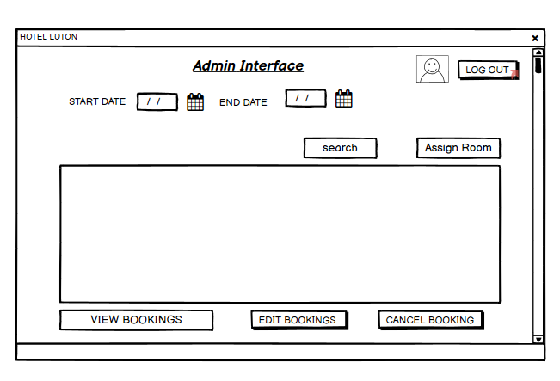

Figure 9 Admin Interface

This is the page which admin or reception gets after login. Receptionist can assign room and approve booking from this interface. She can also view all bookings and rooms that are available from this interface.

# Implementation

Client server system was also implemented, whenever a user interacts with the client either by interaction or by clicking any button then the server receives the request of sending information back to the client. This method was more applicable for the real world

Database can be changed without the frontend user realizing that the change has been made. Also, the good thing is that the user information will not be saved in their computer locally all the data will be stored in server database in separate single, central location.

To begin with the designing part first a database was created. The database that was used is MySQL database. As the syntax is very easy and simple to use, which was very important to use as working with database was a new thing and with no experience. The IDE that was used for creating this project was Eclipse. Windows builder was used for creating the GUI. First, a prototype was designed using Balsamiq Wireframe as it was provided by university itself, all the references were taken from prototype which made the work easier and easy to deal with. Also because of many components and functions which were present in windows builder which made designing GUI easier and faster.

After creating database an ERM was created according to the requirement and all the tables were created in MySQL database and it is connected to java project through java database connector.

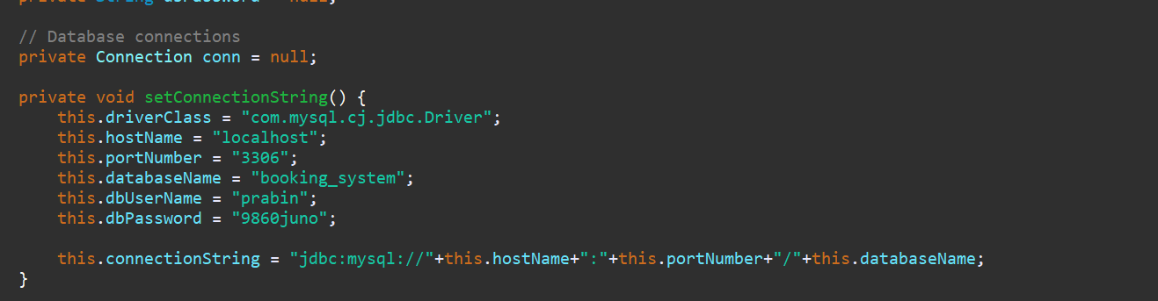

Figure 10 Java database connection

Most of the GUI designing were done using JFrame, JInternalFrame were used in different interface. For this project different packages with different layers were created and making different layer helped in managing and locating errors easier. During the process many problems and errors were faced which were resolved after debugging and proper evaluation. Minor mistakes were made when sending data from frontend to database.

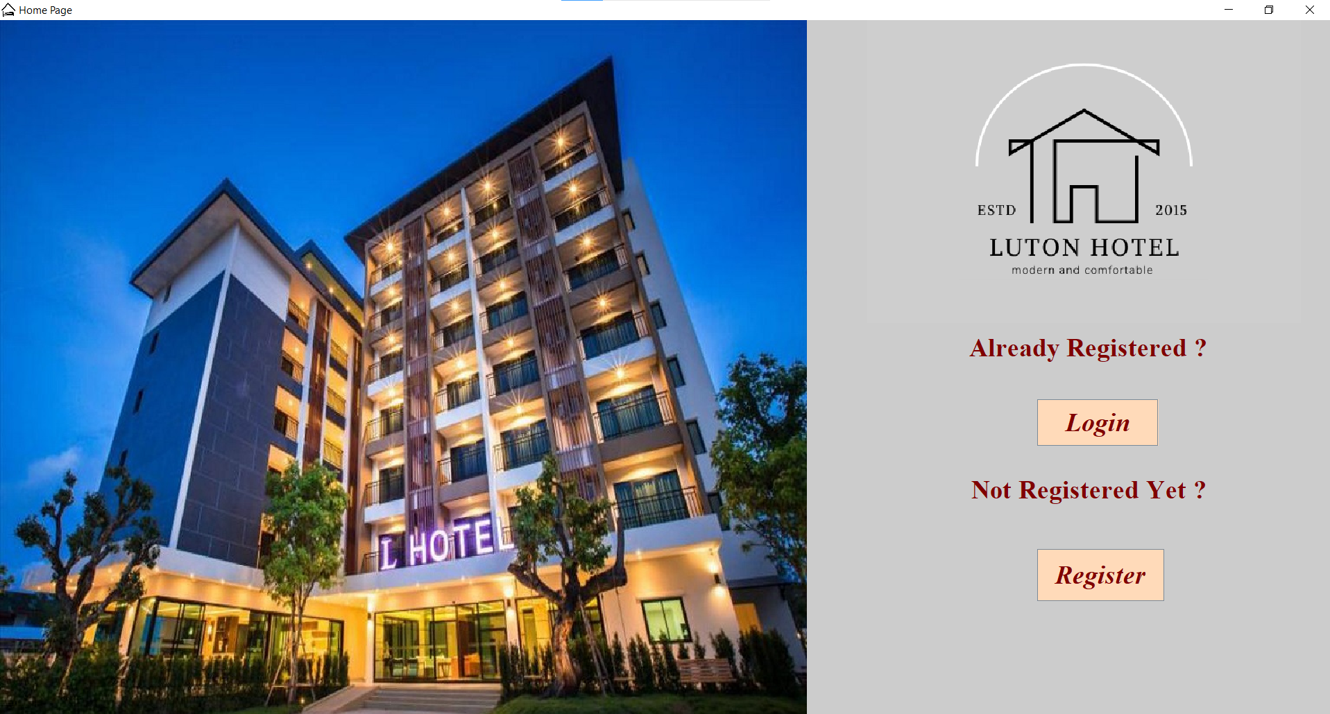

Figure 11 Homepage of Application

This is the home page from where customer who is already registered can login and those who are not registered yet can register and then can make booking.

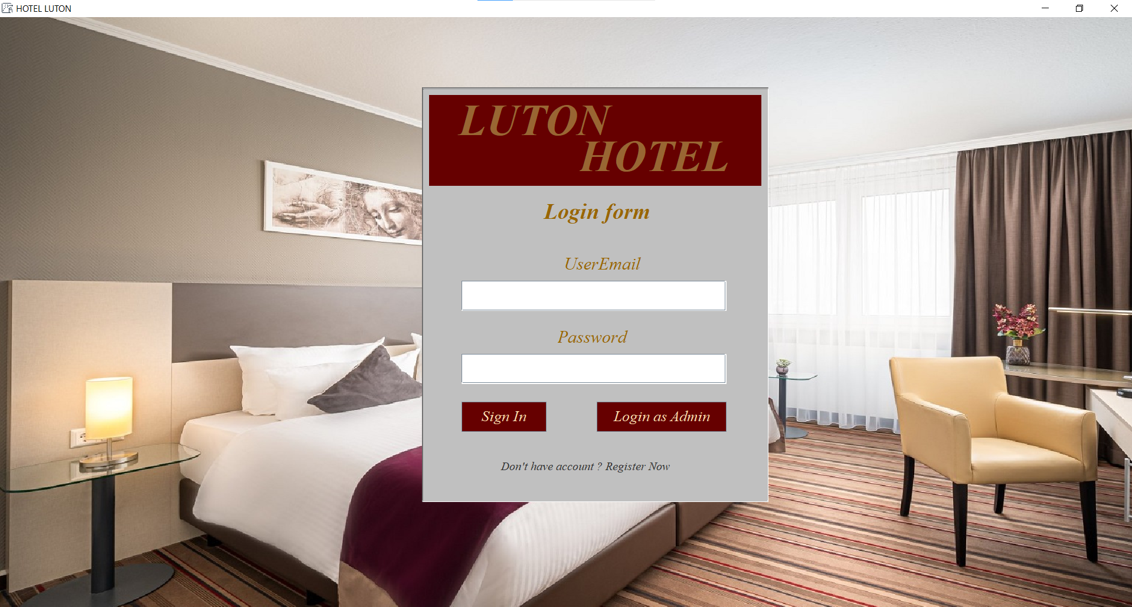

Figure 12 Login Page

This is the login page here customer can enter email and password and then will be redirected to the customer dashboard. Once logged in customer can make, edit, or cancel bookings. Also, from this same page receptionist can also login as admin by providing email and password for admin. Proper validation is given so customer needs to enter email with correct format to login.

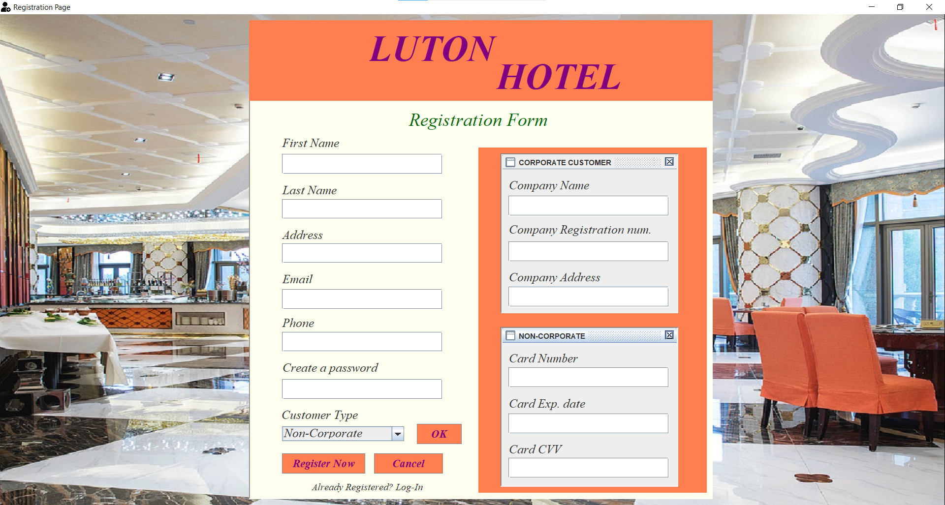

Figure 13 Registration Page

This is the registration page here unregister customer can register themselves by providing their detail all fields must be entered with correct details. For corporate customer company details are mandatory and for non-corporate customer card details is mandatory. As validation is there so proper information should be provided or else error message will be displayed.

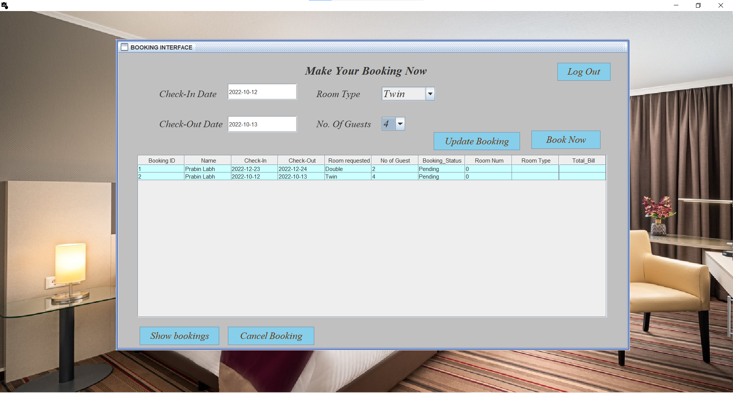

Figure 14 Customer end booking interface

This is the customer dashboard from where customer can request booking and see all his bookings that he made. Customers can also update or cancel any booking he likes.

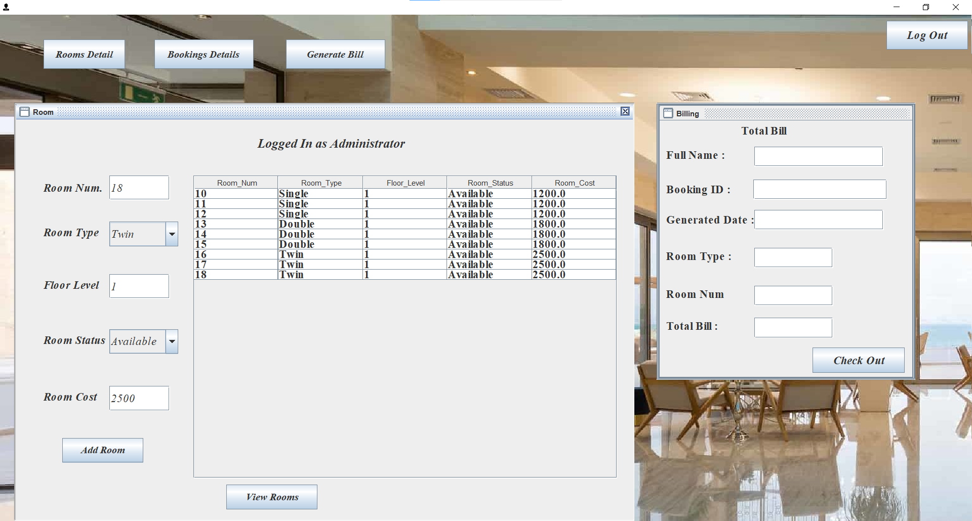

Figure 15 admin interface where receptionist can add room

This is the admin interface there are two different JInternalFrame one for room another for booking. Above picture is for room where receptionist can check the availablilty of of room before assigning room to booking requested.

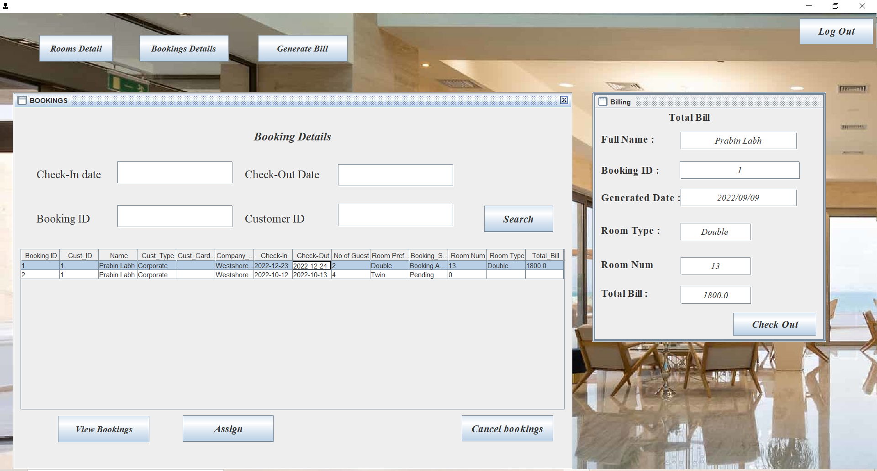

Figure 16 Admin interface where booking is confirmed by assigning room

This is the booking interface of admin dashboard and here receptionist can check the booking request and then assign available room according to the requested room type. Receptionist can also check in guest when arrives, generate bill and do checkout.

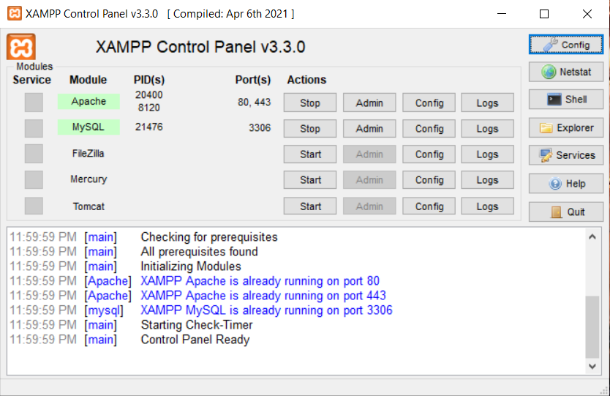

Figure 17 XAMPP WAS USED AS WEB SERVER

Working with xampp and MYSQL database was fun and easy as the syntax and format are much easier to understand and easy to utilize.

# Testing

Testing is done to check whether the application that was created is working as expected or not. The main for this testing was to decrease errors that can occur by the user or input given by user. Following testing were performed which are mentioned below with their screenshot, result expected and actual result are mentioned.

## TEST FOR LOGIN

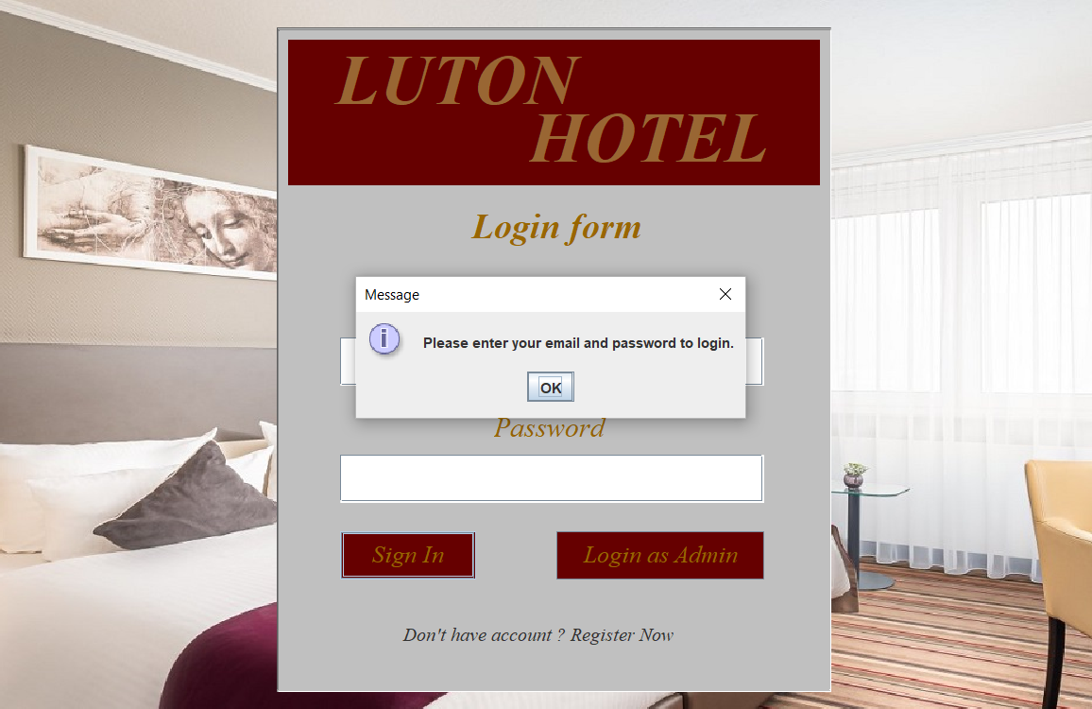

Figure 18 Trying to login without entering email and password

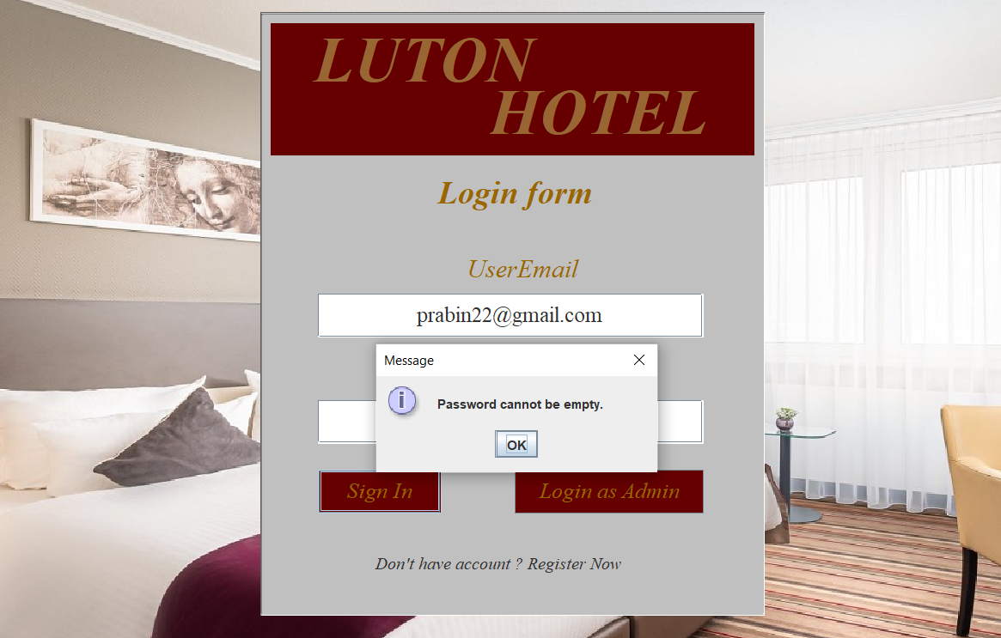

Figure 19 Trying to login without entering password

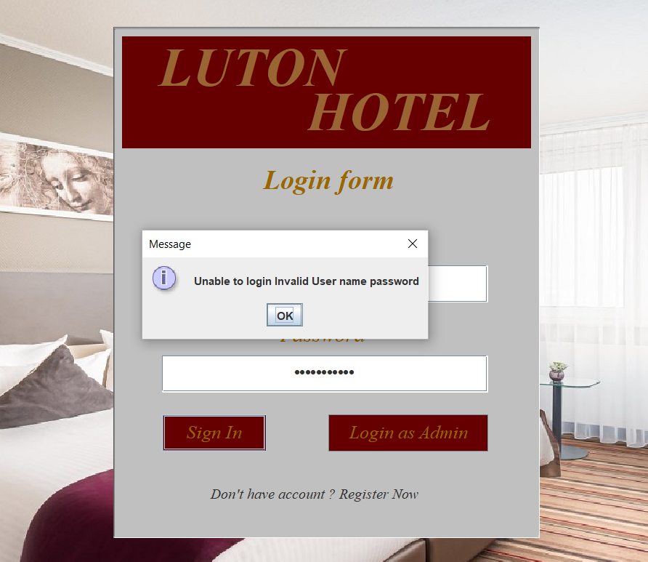

Figure 20 Trying to login by entering incorrect password

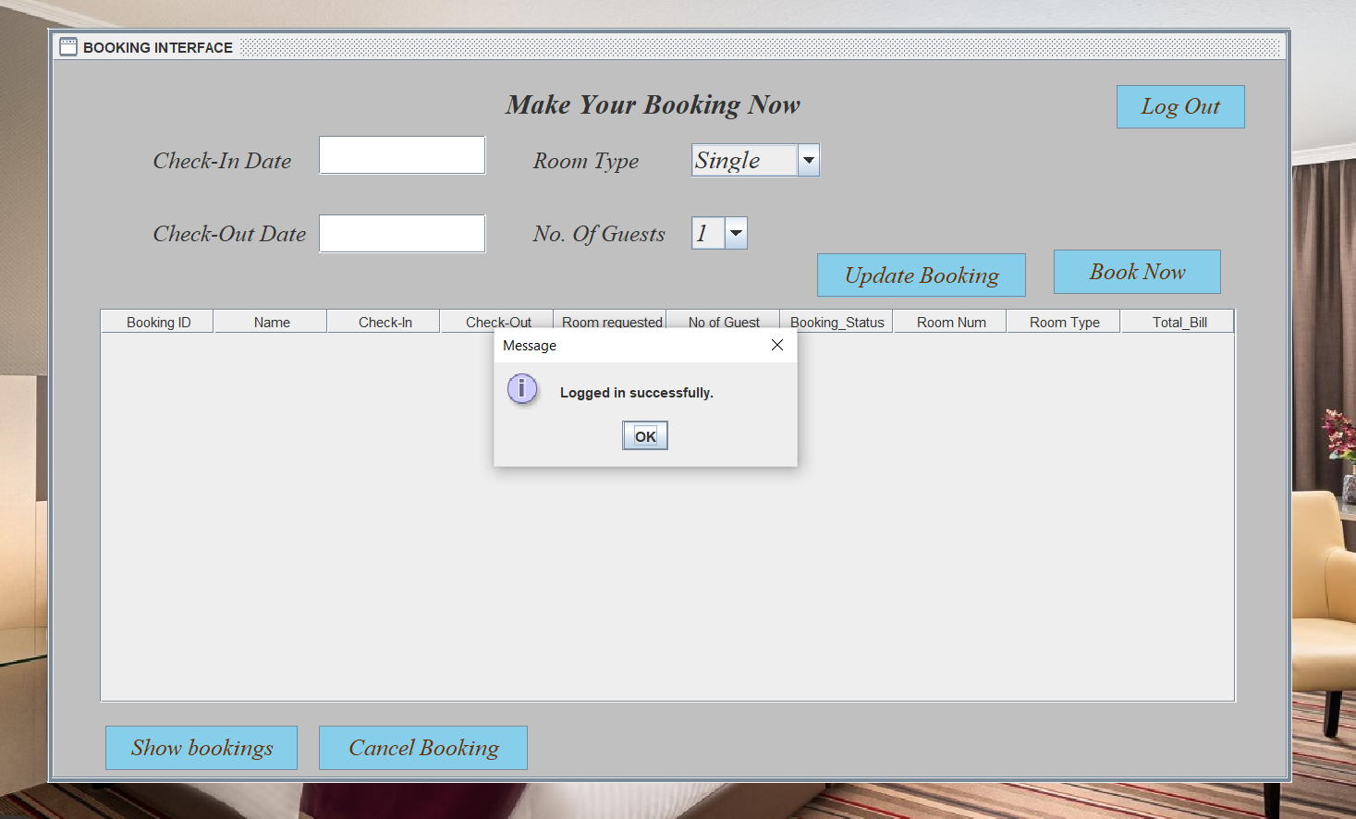

Figure 21 Logged in after entering correct details

|  |  |  |  |  |  |
| --- | --- | --- | --- | --- | --- |
| **Test number** | **Test Case** | **Expected result** | **Actual result** | **status** | **Reference** |
| **1** | Without email and password | Enter detail to login | Enter detail to login | Status | Figure 18 |
| **2** | Entering email only | Enter password | Enter password | Status | Figure 19 |
| **3** | Entering incorrect password | Invalid username or password | Invalid username or password | Status | Figure 20 |
| **4** | Entering correct detail | Logged in successfully | Logged in successfully | Status | Figure 21 |

## TEST FOR REGISTRATION

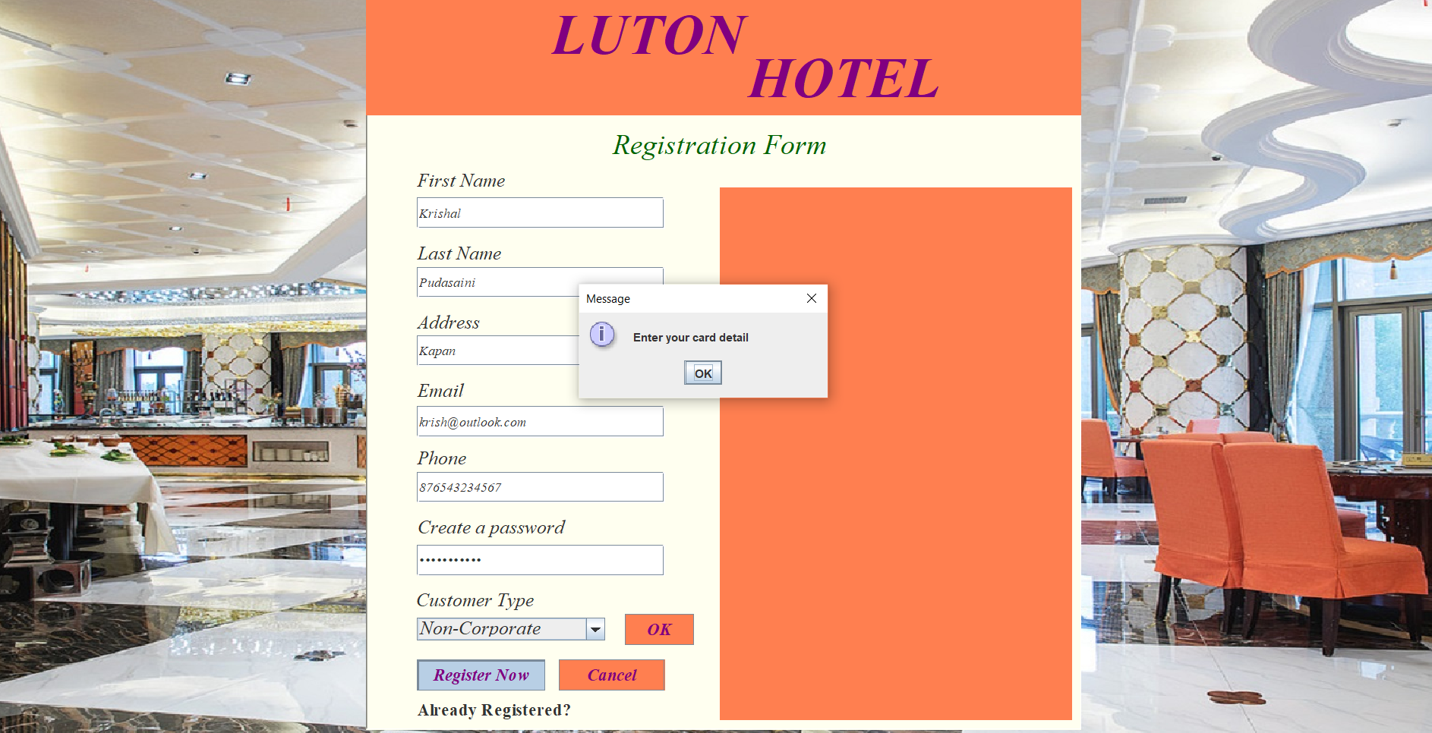

Figure 22 non-corporate customer trying to register without entering card detail

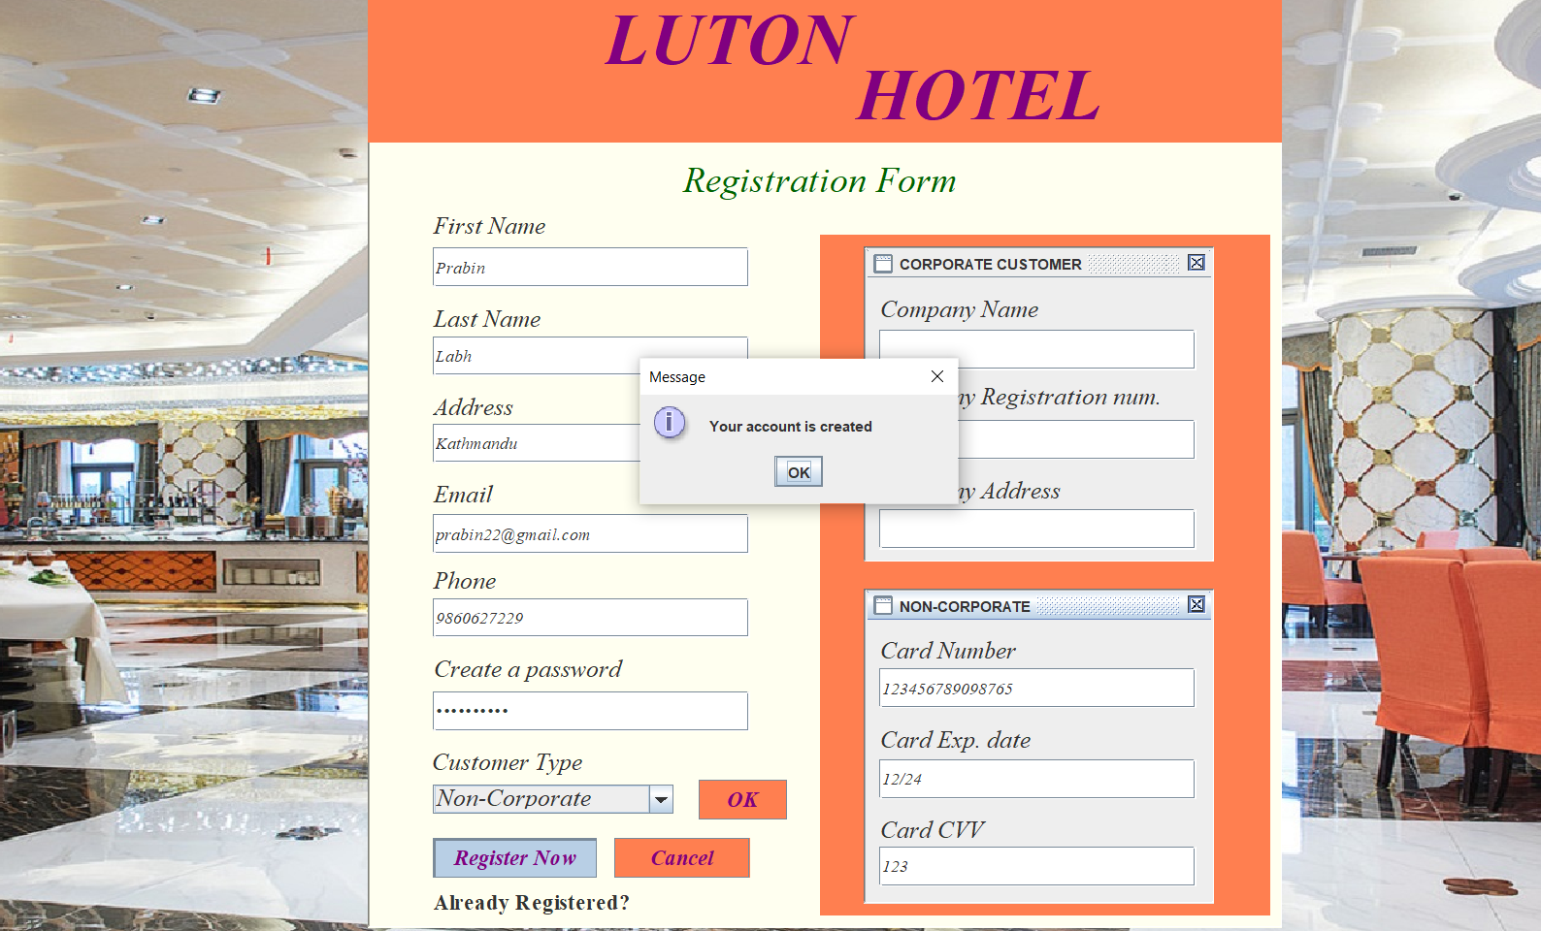

Figure 23 Registration successful

|  |  |  |  |  |  |
| --- | --- | --- | --- | --- | --- |
| **Test number** | **Test Case** | **Expected error** | **Actual error** | **status** | **Reference** |
| **1** | Registering without providing card detail | Please enter card detail | Please enter card detail | Status | Figure 22 |
| **2** | Registration by entering all detail | Account created | Account created | Status | Figure 23 |

## TEST FOR BOOKING

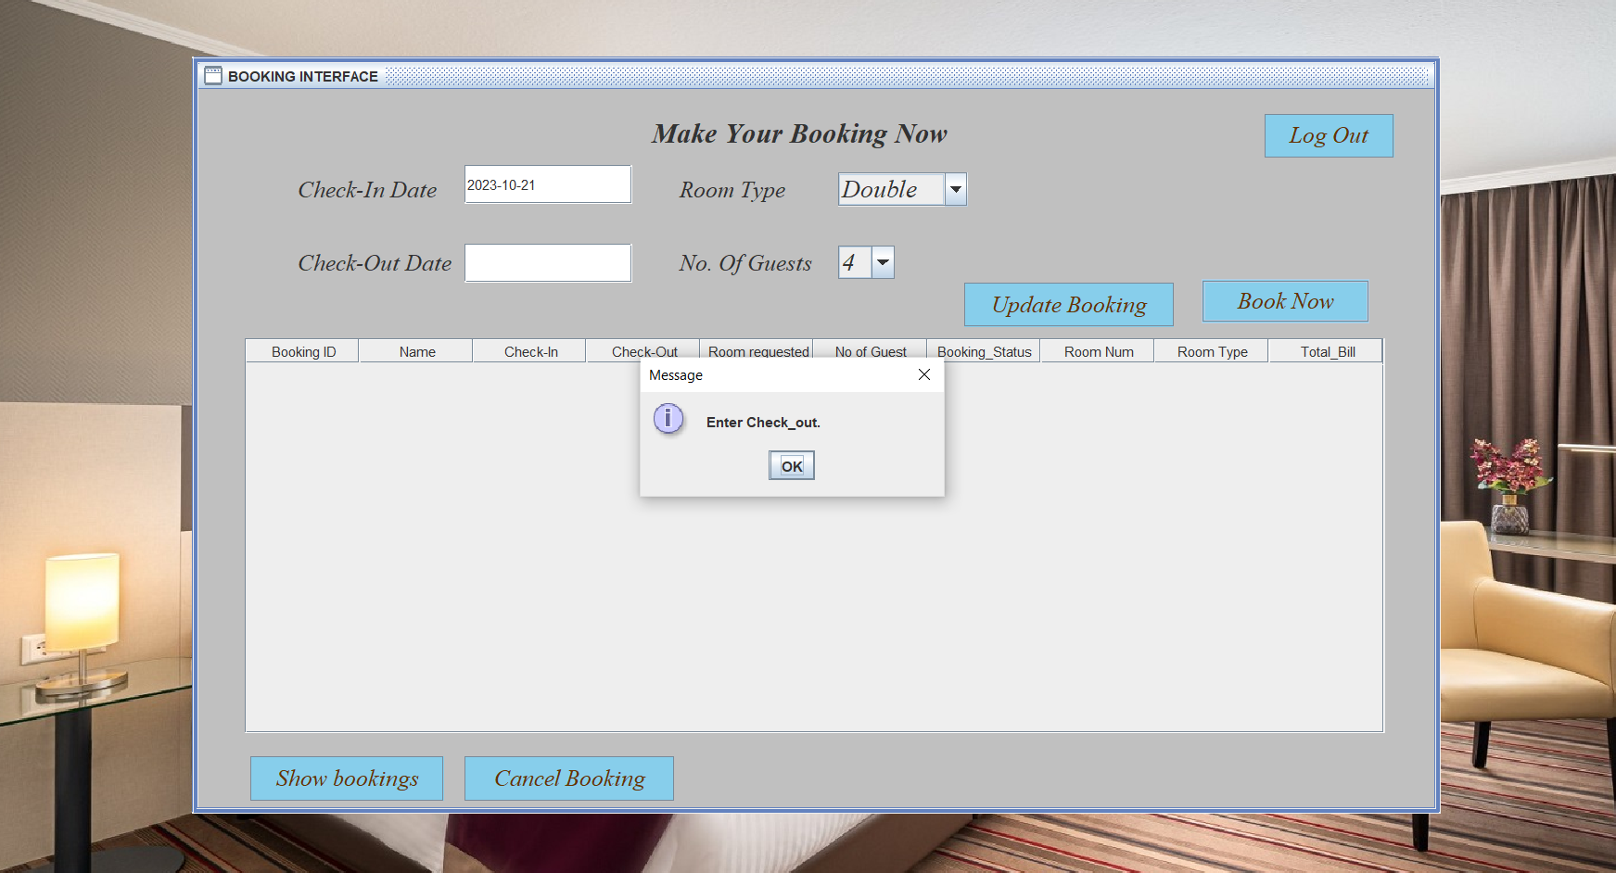

Figure 24 Making booking without giving checkout date

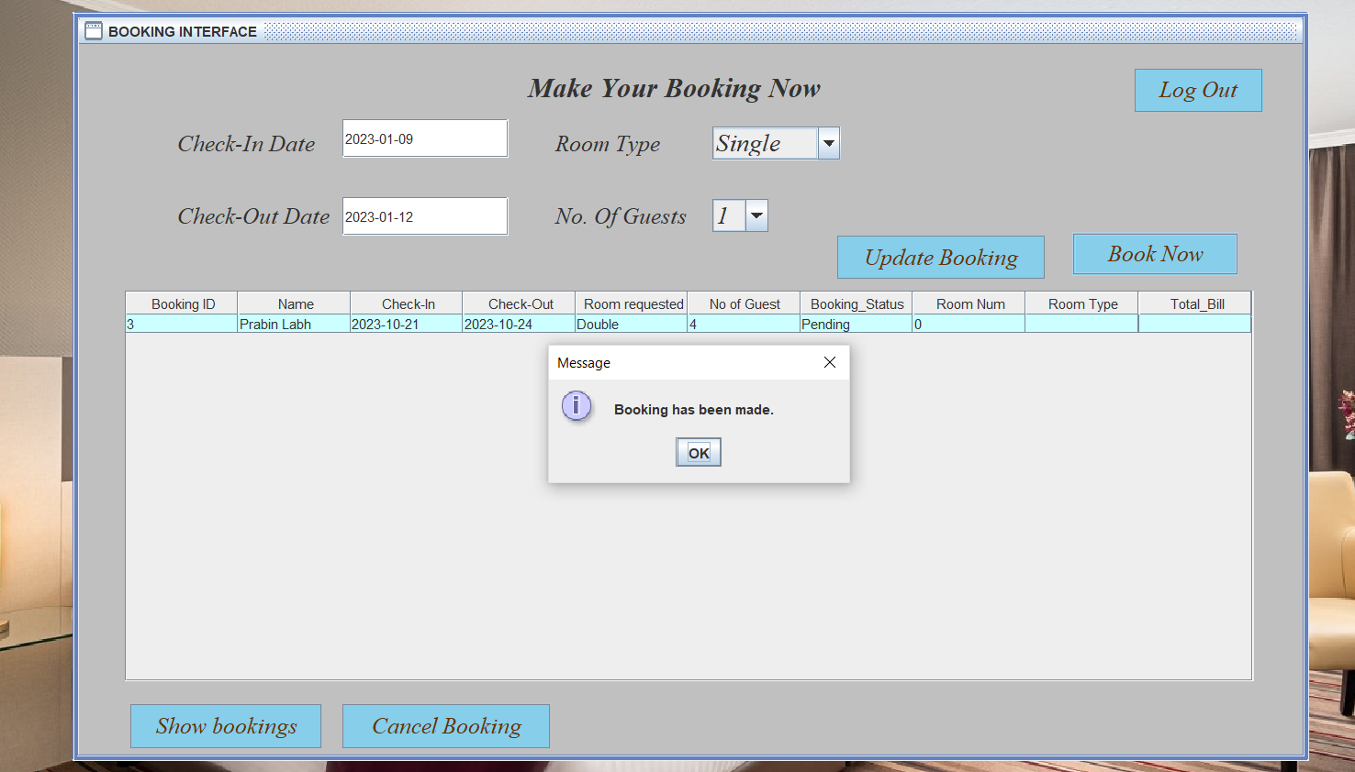

Figure 25 Successful booking made with all bookings in table

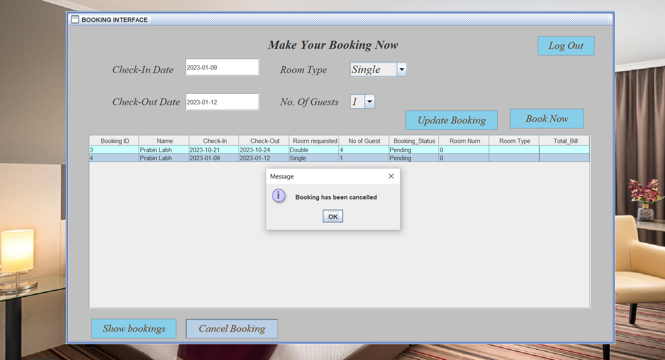

Figure 26 Cancelling Booking that is made already

|  |  |  |  |  |  |
| --- | --- | --- | --- | --- | --- |
| **Test number** | **Test Case** | **Expected result** | **Actual result** | **status** | **Reference** |
| **1** | Making booking without giving check out date | Enter Check-Out date | Enter Check-Out date | Status | Figure 24 |
| **2** | Making a reservation | Booking has been made | Booking has been made | Status | Figure 25 |
| **3** | Cancelling booking | Booking cancelled | Booking cancelled | Status | Figure 26 |

## TEST FOR ADMIN PAGE

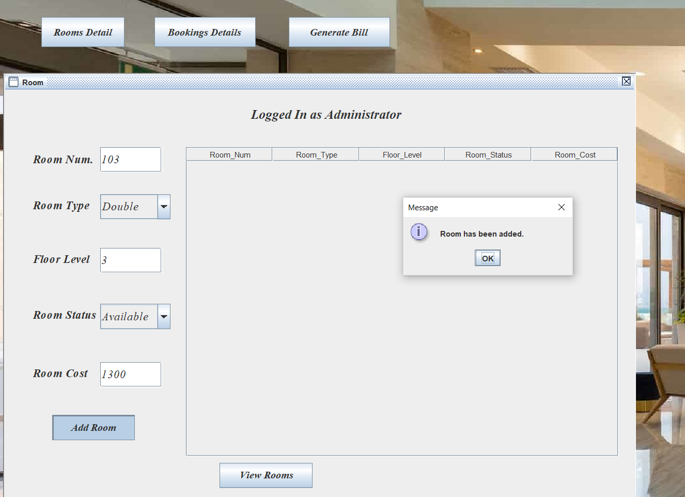

Figure 27 Adding room to table

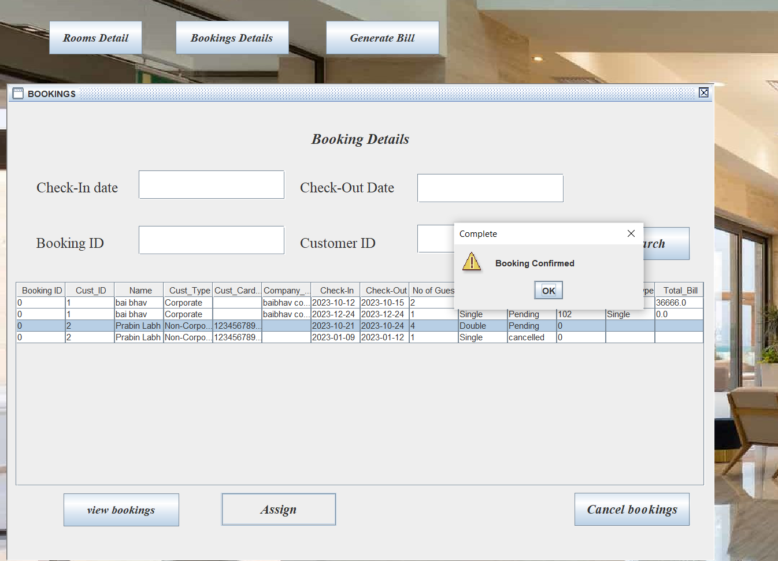

Figure 28 Assigning and confirming booking

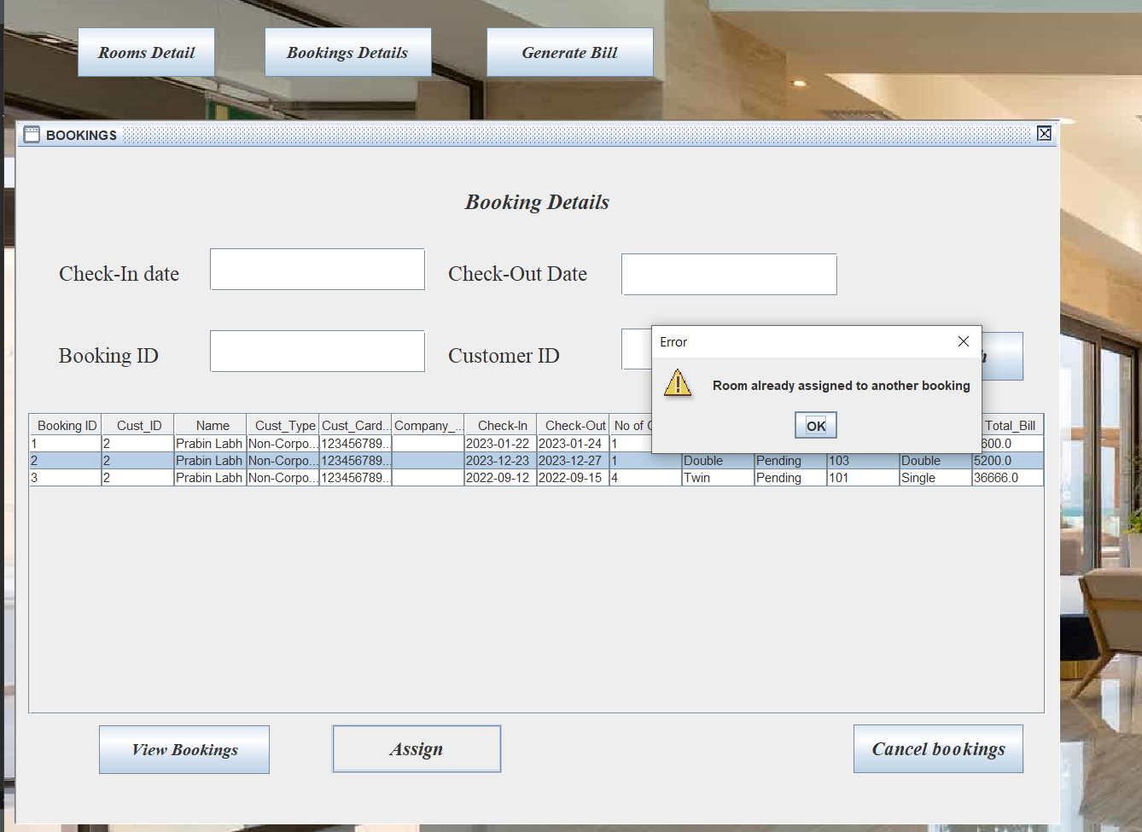

Figure 29 Trying to assign already assigned room

|  |  |  |  |  |  |
| --- | --- | --- | --- | --- | --- |
| **Test number** | **Test Case** | **Expected error** | **Actual error** | **status** | **Reference** |
| **1** | Adding room | Room has been added | Room has been added | Status | Figure 27 |
| **2** | Assigning room to booking | Room Assigned and booking confirmed | Room Assigned and booking confirmed | Status | Figure 28 |
| **3** | Trying to assign booked room | Room already booked | Room already booked | Status | Figure 29 |

# Discussion / Refection / Critical Analysis

The main target of this assignment was to get us familiar with the design and implementation of java in hotel booking system. Everything well during the designing of frontend end as getting deep inside the process and the backend it started getting issues many errors arose. Eclipse IDE and windows builder was used to achieve the final application. At beginning it was difficult to get used to all codes and all as my base is not programming. As started to design and implement it more work finally started getting easier and understandable.

As per the requirement the given task was completed. While creating application many errors came which was solved by doing research or by consulting with faculty member.

Time was enough to complete the task as per the requirement but due to some issue couldn’t give enough time to accomplish the work. Even though the assignment was completed on time. Internet connection issue also gave a hard time sometime. By tackling this assignment, it was much easier to understand about object-oriented programming language. Similarly, also got to know more about java programming language and yes it did motivate to learn deep about programming language.

# Conclusion

This report summarizes the design and implementation for a hotel booking system based on the requirement. The project three tire architecture application which consist of server client and a database that stores data.

For class and use case diagram everything that was required for a system was taken. After that taking the attributes a database tables were created. It was a challenging assignment which was fun and interesting and got to learn more about designing and implementation of java.

The task that was asked was achieved by creating GUI and fully functional hotel booking system. Proper testing was done to the application is performing well.

# References

Song, I. & Chen, P., 2009. *Springer Science Business Media.* [Online]

Available at: https://link.springer.com/referenceworkentry/10.1007/978-0-387-39940-9_148 [Accessed 7 September 2022].

JavaTpoint, 2011-2021. *JavaTpoint.* [Online]   
Available at: https://www.javatpoint.com/uml-class-diagram  
[Accessed 7 Sep 2022].

tutorialspoint, 2022. *TutorialsPoint.* [Online]   
Available at: https://www.tutorialspoint.com/uml/uml_activity_diagram.htm#  
[Accessed 7 Sep 2022].

Walker, A., 2022. *Guru99.* [Online]   
Available at: https://www.guru99.com/use-case-diagrams-example.html  
[Accessed 7 Sep 2022].

# Appendix

// main application

import FrontendLayer.HomePage;

import FrontendLayer.LoginPage;

public class MainApplication {

public static void main (String[] args) {

try {

HomePage window =new HomePage();

window.setVisible(true);

}catch (Exception e) {

e.printStackTrace();

}

}

}

//CONNECTING WITH DATABASE

package Helper;

import java.sql.Connection;

import java.sql.DriverManager;

import java.sql.SQLException;

// This is a Singleton class which creates only one instance object

public class DatabaseConnector {

private static DatabaseConnector *dbInstance* = null;

private String driverClass = null;

private String connectionString = null;

private String hostName = null;

private String portNumber = null;

private String databaseName = null;

private String dbUserName = null;

private String dbPassword = null;

// Database connections

private Connection conn = null;

private void setConnectionString() {

this.driverClass = "com.mysql.cj.jdbc.Driver";

this.hostName = "localhost";

this.portNumber = "3306";

this.databaseName = "booking_system";

this.dbUserName = "prabin";

this.dbPassword = "9860juno";

this.connectionString = "jdbc:mysql://"+this.hostName+":"+this.portNumber+"/"+this.databaseName;

}

private DatabaseConnector() throws Exception {

try {

this.setConnectionString();

Class.*forName*(this.driverClass);

this.conn = DriverManager.*getConnection*(this.connectionString, this.dbUserName, this.dbPassword);

}catch(SQLException ex) {

Exception e = new Exception(ex.getMessage() + " SQL Error Occured");

throw e;

}catch(ClassNotFoundException ex) {

Exception e = new Exception(ex.getMessage() + " Class not found");

throw e;

}

}

public static DatabaseConnector getInstance() throws Exception {

if(*dbInstance* == null) {

try {

*dbInstance* = new DatabaseConnector();

}catch(Exception ex) {

throw ex;

}

}

return *dbInstance*;

}

public Connection getConnection() {

return this.conn;

}

}

// INPUT EXCEPTION

/**

* This class throws the exception when there is input error.

* It has a custom message field which can be set and same message will be passed.

*/

package Helper;

public class InputException extends Exception {

private static final long ***serialVersionUID*** = 1L;

public InputException() {

super("The data you entered is not correct. Please check the input");

}

public InputException(String message) {

super(message);

}

}

//CREATING CUSTOMER MODE

package Models;

public class Customers {

private int cust_ID;

private String cust_FName;

private String cust_LName;

private String address;

private String phone;

private String userEmail;

private String cust_Password;

private Object cust_Type;

private String company_Name;

private String company_address;

private String compRegd_Num;

private String cust_CardNum;

private String cust_CardExp;

private String cust_CardCVV;

public Customers() {

this.cust_ID=0;

this.cust_FName="";

this.cust_LName="";

this.address="";

this.phone="";

this.userEmail="";

this.cust_Password="";

this.cust_Type="";

this.company_Name="";

this.company_address="";

this.compRegd_Num="";

this.cust_CardNum="";

this.cust_CardExp="";

this.cust_CardCVV="";

}

// constructor with parameters

public Customers(int cust_ID, String cust_FName, String cust_LName, String address, String phone, String userEmail,

String cust_Password, String cust_Type, String company_Name, String company_address, String compRegd_Num,

String cust_CardNum, String cust_CardExp, String cust_CardCVV) {

this.cust_ID = cust_ID;

this.cust_FName =cust_FName;

this.cust_LName = cust_LName;

this.address = address;

this.phone = phone;

this.userEmail = userEmail;

this.cust_Password = cust_Password;

this.cust_Type = cust_Type;

this.company_Name = company_Name;

this.company_address = company_address;

this.compRegd_Num = compRegd_Num;

this.cust_CardNum = cust_CardNum;

this.cust_CardExp = cust_CardExp;

this.cust_CardCVV = cust_CardCVV;

}

// creating getter and setter

public int getCust_ID() {

return cust_ID;

}

public void setCust_ID(int cust_ID) {

this.cust_ID = cust_ID;

}

public String getCust_FName() {

return cust_FName;

}

public void setCust_FName(String cust_FName) {

this.cust_FName = cust_FName;

}

public String getCust_LName() {

return cust_LName;

}

public void setCust_LName(String cust_LName) {

this.cust_LName = cust_LName;

}

public String getAddress() {

return address;

}

public void setAddress(String address) {

this.address = address;

}

public String getPhone() {

return phone;

}

public void setPhone(String phone) {

this.phone = phone;

}

public String getUserEmail() {

return userEmail;

}

public void setUserEmail(String userEmail) {

this.userEmail = userEmail;

}

public String getCust_Password() {

return cust_Password;

}

public void setCust_Password(String cust_Password) {

this.cust_Password = cust_Password;

}

public Object getCust_Type() {

return cust_Type;

}

public void setCust_Type(Object object) {

this.cust_Type = object;

}

public String getCompany_Name() {

return company_Name;

}

public void setCompany_Name(String company_Name) {

this.company_Name = company_Name;

}

public String getCompany_address() {

return company_address;

}

public void setCompany_address(String company_address) {

this.company_address = company_address;

}

public String getCompRegd_Num() {

return compRegd_Num;

}

public void setCompRegd_Num(String compRegd_Num) {

this.compRegd_Num = compRegd_Num;

}

public String getCust_CardNum() {

return cust_CardNum;

}

public void setCust_CardNum(String cust_CardNum) {

this.cust_CardNum = cust_CardNum;

}

public String getCust_CardExp() {

return cust_CardExp;

}

public void setCust_CardExp(String cust_CardExp) {

this.cust_CardExp = cust_CardExp;

}

public String getCust_CardCVV() {

return cust_CardCVV;

}

public void setCust_CardCVV(String cust_CardCVV) {

this.cust_CardCVV = cust_CardCVV;

}

}

//CREATING MODEL FOR BOOKINGS

package Models;

//CREATING CLASS BOOKINGS

public class Bookings {

public int bookingID;

private String checkIn_Date;

private String checkOut_Date;

private String room_preference;

private int no_Of_Guests;

private String booking_Status;

private String total_cost;

private String recepID;

private String room_Num;

private int cust_ID ;

public Bookings() {

this.bookingID=0;

this.checkIn_Date ="";

this.checkOut_Date="";

this.room_preference="";

this.no_Of_Guests=0;

this.booking_Status="";

this.total_cost="";

this.recepID="";

this.room_Num="";

this.cust_ID=0 ;

}

public Bookings(int bookingID, String checkIn_Date, String checkOut_Date, String room_preference,

int no_Of_Guests, String booking_Status, String total_cost, String recepID,

String room_Num, int cust_ID) {

this.bookingID = bookingID;

this.checkIn_Date = checkIn_Date;

this.checkOut_Date = checkOut_Date;

this.room_preference = room_preference;

this.no_Of_Guests = no_Of_Guests;

this.booking_Status = booking_Status;

this.total_cost = total_cost;

this.recepID = recepID;

this.room_Num = room_Num;

this.cust_ID = cust_ID;

}

// CREATING GETTER AND SETTERS

public int getBookingID() {

return bookingID;

}

public void setBookingID(int bookingID) {

this.bookingID = bookingID;

}

public String getCheckIn_Date() {

return checkIn_Date;

}

public void setCheckIn_Date(String checkin) {

this.checkIn_Date = checkin;

}

public String getCheckOut_Date() {

return checkOut_Date;

}

public void setCheckOut_Date(String checkout) {

this.checkOut_Date = checkout;

}

public String getRoom_preference() {

return room_preference;

}

public void setRoom_preference(String object) {

room_preference = object;

}

public int getNo_Of_Guests() {

return this.no_Of_Guests;

}

public void setNo_Of_Guests(int no) {

this.no_Of_Guests = no;

}

public String getBooking_Status() {

return booking_Status;

}

public void setBooking_Status(String booking_Status) {

this.booking_Status = booking_Status;

}

public String getTotal_cost() {

return total_cost;

}

public void setTotal_cost(String total_cost) {

this.total_cost = total_cost;

}

public String getRecepID() {

return recepID;

}

public void setRecepID(String recepID) {

this.recepID = recepID;

}

public String getRoom_Num() {

return room_Num;

}

public void setRoom_Num(String room_Num) {

this.room_Num = room_Num;

}

public int getCust_ID() {

return cust_ID;

}

public void setCust_ID(int cust_ID) {

this.cust_ID = cust_ID;

}

}

//CREATING MODEL FOR ROOM

package Models;

//CREATING CLASS ROOM

public class Room {

private String room_Num;

private Object room_Type;

private String floor_Level;

private Object room_Status;

private String room_Cost;

public Room() {

this.room_Num = "";

this.room_Type = "";

this.floor_Level = "";

this.room_Status = "";

this.room_Cost= "" ;

}

public Room(String room_Num, String room_Type, String floor_Level, String Room_Status, String room_Cost) {

this.room_Num = room_Num;

this.room_Type = room_Type;

this.floor_Level = floor_Level;

this.room_Cost = room_Cost;

}

//CREATING GETTER AND SETTER

public String getRoom_Num() {

return room_Num;

}

public void setRoom_Num(String room_Num) {

this.room_Num = room_Num;

}

public Object getRoom_Type() {

return room_Type;

}

public void setRoom_Type(Object room_Type) {

this.room_Type = room_Type;

}

public String getFloor_Level() {

return floor_Level;

}

public void setFloor_Level(String floor_Level) {

this.floor_Level = floor_Level;

}

public Object getRoom_Status() {

return room_Status;

}

public void setRoom_Status(Object room_Status) {

this.room_Status = room_Status;

}

public String getRoom_Cost() {

return room_Cost;

}

public void setRoom_Cost(String room_Cost) {

this.room_Cost = room_Cost;

}

}

// CREATING MODEL FOR RECEPTIONIST

package Models;

//CREATING CLASS rECEPTIONIST

public class Receptionist {

private int recepId ;

private String name ;

private String address ;

private String email ;

private String phone ;

private String password ;

public Receptionist() {

this.recepId=0;

this.name="";

this.address="";

this.email="";

this.phone="";

this.password="";

}

public Receptionist(int recepId, String name, String address, String email, String phone, String password) {

super();

this.recepId = recepId;

this.name = name;

this.address = address;

this.email = email;

this.phone = phone;

this.password = password;

}

//CREATING GETTER AND SETTER

public int getRecepId() {

return recepId;

}

public void setRecepId(int recepId) {

this.recepId = recepId;

}

public String getName() {

return name;

}

public void setName(String name) {

this.name = name;

}

public String getAddress() {

return address;

}

public void setAddress(String address) {

this.address = address;

}

public String getEmail() {

return email;

}

public void setEmail(String email) {

this.email = email;

}

public String getPhone() {

return phone;

}

public void setPhone(String phone) {

this.phone = phone;

}

public String getPassword() {

return password;

}

public void setPassword(String password) {

this.password = password;

}

}

//CREATING MODEL INVOICE

package Models;

public class Invoice {

private int recepID;

private int invoiceID;

private String generatedDate;

private double Total_Amount;

public Invoice() {

recepID=0;

invoiceID=0;

generatedDate ="";

Total_Amount =0.0;

}

public Invoice(int recepID, int invoiceID, String generatedDate, double total_Amount) {

super();

this.recepID = recepID;

this.invoiceID = invoiceID;

this.generatedDate = generatedDate;

Total_Amount = total_Amount;

}

public int getRecepID() {

return recepID;

}

public void setRecepID(int recepID) {

this.recepID = recepID;

}

public int getInvoiceID() {

return invoiceID;

}

public void setInvoiceID(int invoiceID) {

this.invoiceID = invoiceID;

}

public String getGeneratedDate() {

return generatedDate;

}

public void setGeneratedDate(String generatedDate) {

this.generatedDate = generatedDate;

}

public double getTotal_Amount() {

return Total_Amount;

}

public void setTotal_Amount(double total_Amount) {

Total_Amount = total_Amount;

}

}

// CREATING DEFAULT TABLE

package Models;

//CREATING CLASS DEFAULTMODELS

public class DefaultModels {

private String name ;

private int reservationid;

private String adminaddress ;

private String adminemail ;

private String adminphone ;

private String password ;

private int bookingID;

private int RoomNum;

private String checkIn_Date;

private String checkOut_Date;

private Object room_preference;

private Object no_Of_Guests;

private Object no_Of_Rooms;

private String booking_Status;

private String totaL_Cost;

private String recepID;

private int cust_ID;

private String custaddress;

private String custphone;

private String userEmail;

private String cust_Password;

private Object cust_Type;

private String company_Name;

private String company_address;

private String compRegd_Num;

private String cust_CardNum;

private String cust_CardExp;

private String cust_CardCVV;

private int Room_Num;

private Object Room_Type;

private String Floor_Level;

private Object Room_Status;

private String Room_Cost;

public DefaultModels() {

this.name="";

this.reservationid=0;

this.adminaddress="";

this.adminemail="";

this.adminphone="";

this.password="";

this.bookingID =0;

this.RoomNum=0;

this.checkIn_Date ="";

this.checkOut_Date="";

this.room_preference="";

this.no_Of_Guests="";

this.no_Of_Rooms="";

this.booking_Status="";

this.totaL_Cost="";

this.recepID="";

this.cust_ID=0 ;

this.custaddress="";

this.custphone="";

this.userEmail="";

this.cust_Password="";

this.cust_Type="";

this.company_Name="";

this.company_address="";

this.compRegd_Num="";

this.cust_CardNum="";

this.cust_CardExp="";

this.cust_CardCVV="";

this.Room_Num = 0;

this.Room_Type = "";

this.Floor_Level = "";

this.Room_Status = "";

this.Room_Cost= "" ;

}

public String getName() {

return name;

}

public void setName(String name) {

this.name = name;

}

public int getReservationid() {

return reservationid;

}

public void setReservationid(int reservationid) {

this.reservationid = reservationid;

}

public String getAdminaddress() {

return adminaddress;

}

public void setAdminaddress(String adminaddress) {

this.adminaddress = adminaddress;

}

public String getAdminemail() {

return adminemail;

}

public void setAdminemail(String adminemail) {

this.adminemail = adminemail;

}

public String getAdminphone() {

return adminphone;

}

public void setAdminphone(String adminphone) {

this.adminphone = adminphone;

}

public String getPassword() {

return password;

}

public void setPassword(String password) {

this.password = password;

}

public int getBookingID() {

return bookingID;

}

public void setBookingID(int bookingID) {

this.bookingID = bookingID;

}

public int getRoomNum() {

return RoomNum;

}

public void setRoomNum(int roomNum) {

RoomNum = roomNum;

}

public String getCheckIn_Date() {

return checkIn_Date;

}

public void setCheckIn_Date(String checkIn_Date) {

this.checkIn_Date = checkIn_Date;

}

public String getCheckOut_Date() {

return checkOut_Date;

}

public void setCheckOut_Date(String checkOut_Date) {

this.checkOut_Date = checkOut_Date;

}

public Object getRoom_preference() {

return room_preference;

}

public void setRoom_preference(Object room_preference) {

this.room_preference = room_preference;

}

public Object getNo_Of_Guests() {

return no_Of_Guests;

}

public void setNo_Of_Guests(Object no_Of_Guests) {

this.no_Of_Guests = no_Of_Guests;

}

public Object getNo_Of_Rooms() {

return no_Of_Rooms;

}

public void setNo_Of_Rooms(Object no_Of_Rooms) {

this.no_Of_Rooms = no_Of_Rooms;

}

public String getBooking_Status() {

return booking_Status;

}

public void setBooking_Status(String booking_Status) {

this.booking_Status = booking_Status;

}

public String getTotaL_Cost() {

return totaL_Cost;

}

public void setTotaL_Cost(String totaL_Cost) {

this.totaL_Cost = totaL_Cost;

}

public String getRecepID() {

return recepID;

}

public void setRecepID(String recepID) {

this.recepID = recepID;

}

public int getCust_ID() {

return cust_ID;

}

public void setCust_ID(int cust_ID) {

this.cust_ID = cust_ID;

}

public String getCustaddress() {

return custaddress;

}

public void setCustaddress(String custaddress) {

this.custaddress = custaddress;

}

public String getCustphone() {

return custphone;

}

public void setCustphone(String custphone) {

this.custphone = custphone;

}

public String getUserEmail() {

return userEmail;

}

public void setUserEmail(String userEmail) {

this.userEmail = userEmail;

}

public String getCust_Password() {

return cust_Password;

}

public void setCust_Password(String cust_Password) {

this.cust_Password = cust_Password;

}

public Object getCust_Type() {

return cust_Type;

}

public void setCust_Type(Object cust_Type) {

this.cust_Type = cust_Type;

}

public String getCompany_Name() {

return company_Name;

}

public void setCompany_Name(String company_Name) {

this.company_Name = company_Name;

}

public String getCompany_address() {

return company_address;

}

public void setCompany_address(String company_address) {

this.company_address = company_address;

}

public String getCompRegd_Num() {

return compRegd_Num;

}

public void setCompRegd_Num(String compRegd_Num) {

this.compRegd_Num = compRegd_Num;

}

public String getCust_CardNum() {

return cust_CardNum;

}

public void setCust_CardNum(String cust_CardNum) {

this.cust_CardNum = cust_CardNum;

}

public String getCust_CardExp() {

return cust_CardExp;

}

public void setCust_CardExp(String cust_CardExp) {

this.cust_CardExp = cust_CardExp;

}

public String getCust_CardCVV() {

return cust_CardCVV;

}

public void setCust_CardCVV(String cust_CardCVV) {

this.cust_CardCVV = cust_CardCVV;

}

public int getRoom_Num() {

return Room_Num;

}

public void setRoom_Num(int room_Num) {

Room_Num = room_Num;

}

public Object getRoom_Type() {

return Room_Type;

}

public void setRoom_Type(Object room_Type) {

Room_Type = room_Type;

}

public String getFloor_Level() {

return Floor_Level;

}

public void setFloor_Level(String floor_Level) {

Floor_Level = floor_Level;

}

public Object getRoom_Status() {

return Room_Status;

}

public void setRoom_Status(Object room_Status) {

Room_Status = room_Status;

}

public String getRoom_Cost() {

return Room_Cost;

}

public void setRoom_Cost(String room_Cost) {

Room_Cost = room_Cost;

}

}

FRONTEND GUI DESIGNING CODES

// Home PAGE

package FrontendLayer;

import javax.swing.JFrame;

import javax.swing.JPanel;

import javax.swing.border.EmptyBorder;

import javax.swing.JLabel;

import javax.swing.JOptionPane;

import javax.swing.BorderFactory;

import javax.swing.ImageIcon;

import javax.swing.JDesktopPane;

import javax.swing.SwingConstants;

import java.awt.Font;

import java.awt.Color;

import javax.swing.JTextField;

import javax.swing.JPasswordField;

import javax.swing.JButton;

import javax.swing.border.SoftBevelBorder;

import BusinessLayer.BLCustomers;

import BusinessLayer.BLReceptionist;

import Helper.InputException;

import Models.Customers;

import Models.Receptionist;

import javax.swing.border.BevelBorder;

import javax.swing.border.Border;

import java.awt.Toolkit;

import java.awt.event.ActionListener;

import java.awt.event.ActionEvent;

public class LoginPage extends JFrame {

/**

*

*/

private JPanel contentPane;

private JTextField txtcustemail;

private JPasswordField txtcustLoginPass;

/**

* Create the frame.

*/

public LoginPage() {

setTitle("HOTEL LUTON");

setIconImage(Toolkit.*getDefaultToolkit*().getImage("C:\\Users\\ucc\\eclipse-workspace\\Luton_Application\\src\\login.png"));

setDefaultCloseOperation(JFrame.***EXIT_ON_CLOSE***);

setBounds(0, 0, 1920, 1080);

contentPane = new JPanel();

contentPane.setBackground(Color.***GRAY***);

contentPane.setBorder(new EmptyBorder(5, 5, 5, 5));

setContentPane(contentPane);

contentPane.setLayout(null);

JDesktopPane desktopPane = new JDesktopPane();

desktopPane.setBorder(new SoftBevelBorder(BevelBorder.***LOWERED***, null, null, null, null));

desktopPane.setBackground(Color.***LIGHT_GRAY***);

desktopPane.setBounds(572, 96, 470, 562);

contentPane.add(desktopPane);

JPanel panel = new JPanel();

desktopPane.setLayer(panel, 0);

panel.setBackground(new Color(102, 0, 0));

panel.setBounds(10, 10, 450, 123);

desktopPane.add(panel);

panel.setLayout(null);

JLabel hotelFname = new JLabel(" LUTON\r\n");

hotelFname.setForeground(new Color(153, 102, 51));

panel.add(hotelFname);

hotelFname.setBounds(10,0,287,58);

hotelFname.setHorizontalAlignment(SwingConstants.***LEFT***);

hotelFname.setVerticalAlignment(SwingConstants.***TOP***);

hotelFname.setFont(new Font("Times New Roman", Font.***BOLD*** | Font.***ITALIC***, 60));

JLabel hotelLname = new JLabel("HOTEL");

hotelLname.setForeground(new Color(153, 102, 51));

hotelLname.setFont(new Font("Times New Roman", Font.***BOLD*** | Font.***ITALIC***, 60));

hotelLname.setBounds(204, 55, 236, 58);

panel.add(hotelLname);

JLabel titleform = new JLabel("Login form\r\n");

titleform.setForeground(new Color(153, 102, 0));

titleform.setFont(new Font("Times New Roman", Font.***BOLD*** | Font.***ITALIC***, 30));

titleform.setHorizontalAlignment(SwingConstants.***CENTER***);

titleform.setBounds(92, 143, 293, 50);

desktopPane.add(titleform);

JLabel lblEmail = new JLabel("UserEmail");

lblEmail.setForeground(new Color(153, 102, 0));

lblEmail.setFont(new Font("Times New Roman", Font.***ITALIC***, 24));

lblEmail.setBounds(192, 227, 107, 25);

desktopPane.add(lblEmail);

JLabel lblPassword = new JLabel("Password\r\n");

lblPassword.setForeground(new Color(153, 102, 0));

lblPassword.setFont(new Font("Times New Roman", Font.***ITALIC***, 24));

lblPassword.setBounds(184, 326, 162, 25);

desktopPane.add(lblPassword);

txtcustemail = new JTextField();

txtcustemail.setToolTipText("Enter your email");

txtcustemail.setHorizontalAlignment(SwingConstants.***CENTER***);

txtcustemail.setFont(new Font("Times New Roman", Font.***PLAIN***, 20));

txtcustemail.setBounds(54, 262, 359, 41);

desktopPane.add(txtcustemail);

txtcustemail.setColumns(10);

txtcustLoginPass = new JPasswordField();

txtcustLoginPass.setFont(new Font("Times New Roman", Font.***PLAIN***, 20));

txtcustLoginPass.setHorizontalAlignment(SwingConstants.***CENTER***);

txtcustLoginPass.setToolTipText("Enter your login password ");

txtcustLoginPass.setBounds(54, 361, 359, 41);

desktopPane.add(txtcustLoginPass);

JButton btnSignIn = new JButton("Sign In");

btnSignIn.addActionListener(new ActionListener() {

public void actionPerformed(ActionEvent e) {

userSignIn();

}

});

btnSignIn.setBackground(new Color(102, 0, 0));

btnSignIn.setForeground(new Color(255, 222, 173));

btnSignIn.setFont(new Font("Times New Roman", Font.***ITALIC***, 20));

btnSignIn.setBounds(54, 426, 115, 41);

desktopPane.add(btnSignIn);

btnSignIn.setFocusable(false);

JButton btnLoginAsAdmin = new JButton("Login as Admin");

desktopPane.setLayer(btnLoginAsAdmin, 0);

btnLoginAsAdmin.addActionListener(new ActionListener() {

public void actionPerformed(ActionEvent e) {

adminSignIn();

}

});

btnLoginAsAdmin.setForeground(new Color(255, 222, 173));

btnLoginAsAdmin.setFont(new Font("Times New Roman", Font.***ITALIC***, 20));

btnLoginAsAdmin.setBackground(new Color(102, 0, 0));

btnLoginAsAdmin.setBounds(237, 426, 176, 41);

desktopPane.add(btnLoginAsAdmin);

JButton btnSignup = new JButton("Don't have account ? Register Now ");

desktopPane.setLayer(btnSignup, 0);

btnSignup.setFont(new Font("Times New Roman", Font.***ITALIC***, 16));

btnSignup.addActionListener(new ActionListener() {

public void actionPerformed(ActionEvent e) {

dispose();

RegisterPage regpage = new RegisterPage();

regpage.setVisible(true);

}

});

btnSignup.setBackground(Color.***LIGHT_GRAY***);

btnSignup.setBounds(101, 502, 245, 25);

desktopPane.add(btnSignup);

Border emptyBorder = BorderFactory.*createEmptyBorder*();

btnSignup.setBorder(emptyBorder);

btnSignIn.setFocusable(false);

JLabel lblwallpaper = new JLabel("");

lblwallpaper.setIcon(new ImageIcon("C:\\Users\\ucc\\eclipse-workspace\\Luton_Application\\src\\bedroom.jpeg"));

lblwallpaper.setBounds(0, 0, 1750, 900);

contentPane.add(lblwallpaper);

}

private void userSignIn() {

try {

Customers customers = new Customers();

customers.setUserEmail(txtcustemail.getText());

customers.setCust_Password(String.*valueOf*(txtcustLoginPass.getPassword()));

BLCustomers userBL = new BLCustomers();

userBL.ValidateUserSignIn(customers);

userBL.userSignIn(customers);

}

catch(InputException ex) {

JOptionPane.*showMessageDialog*(null, ex.getMessage());

}

catch(Exception ex) {

JOptionPane.*showMessageDialog*(null, ex.getMessage());

}

}

private void adminSignIn() {

try {

Receptionist recept = new Receptionist();

recept.setEmail(txtcustemail.getText());

recept.setPassword(String.*valueOf*(txtcustLoginPass.getPassword()));

BLReceptionist adminBL = new BLReceptionist();

adminBL.ValidateadminSignIn(recept);

adminBL.adminSignIn(recept);

}

catch(InputException ex) {

JOptionPane.*showMessageDialog*(null, ex.getMessage());

}

catch(Exception ex) {

JOptionPane.*showMessageDialog*(null, ex.getMessage());

}

}

}

// Login page//

package FrontendLayer;

import javax.swing.JFrame;

import javax.swing.JPanel;

import javax.swing.border.EmptyBorder;

import javax.swing.JLabel;

import javax.swing.JOptionPane;

import javax.swing.BorderFactory;

import javax.swing.ImageIcon;

import javax.swing.JDesktopPane;

import javax.swing.SwingConstants;

import java.awt.Font;

import java.awt.Color;

import javax.swing.JTextField;

import javax.swing.JPasswordField;

import javax.swing.JButton;

import javax.swing.border.SoftBevelBorder;

import BusinessLayer.BLCustomers;

import BusinessLayer.BLReceptionist;

import Helper.InputException;

import Models.Customers;

import Models.Receptionist;

import javax.swing.border.BevelBorder;

import javax.swing.border.Border;

import java.awt.Toolkit;

import java.awt.event.ActionListener;

import java.awt.event.ActionEvent;

public class LoginPage extends JFrame {

/**

*

*/

private JPanel contentPane;

private JTextField txtcustemail;

private JPasswordField txtcustLoginPass;

/**

* Create the frame.

*/

public LoginPage() {

setTitle("HOTEL LUTON");

setIconImage(Toolkit.getDefaultToolkit().getImage("C:\\Users\\ucc\\eclipse-workspace\\Luton_Application\\src\\login.png"));

setDefaultCloseOperation(JFrame.EXIT_ON_CLOSE);

setBounds(0, 0, 1920, 1080);

contentPane = new JPanel();

contentPane.setBackground(Color.GRAY);

contentPane.setBorder(new EmptyBorder(5, 5, 5, 5));

setContentPane(contentPane);

contentPane.setLayout(null);

JDesktopPane desktopPane = new JDesktopPane();

desktopPane.setBorder(new SoftBevelBorder(BevelBorder.LOWERED, null, null, null, null));

desktopPane.setBackground(Color.LIGHT_GRAY);

desktopPane.setBounds(572, 96, 470, 562);

contentPane.add(desktopPane);

JPanel panel = new JPanel();

desktopPane.setLayer(panel, 0);

panel.setBackground(new Color(102, 0, 0));

panel.setBounds(10, 10, 450, 123);

desktopPane.add(panel);

panel.setLayout(null);

JLabel hotelFname = new JLabel(" LUTON\r\n");

hotelFname.setForeground(new Color(153, 102, 51));

panel.add(hotelFname);

hotelFname.setBounds(10,0,287,58);

hotelFname.setHorizontalAlignment(SwingConstants.LEFT);

hotelFname.setVerticalAlignment(SwingConstants.TOP);

hotelFname.setFont(new Font("Times New Roman", Font.BOLD | Font.ITALIC, 60));

JLabel hotelLname = new JLabel("HOTEL");

hotelLname.setForeground(new Color(153, 102, 51));

hotelLname.setFont(new Font("Times New Roman", Font.BOLD | Font.ITALIC, 60));

hotelLname.setBounds(204, 55, 236, 58);

panel.add(hotelLname);

JLabel titleform = new JLabel("Login form\r\n");

titleform.setForeground(new Color(153, 102, 0));

titleform.setFont(new Font("Times New Roman", Font.BOLD | Font.ITALIC, 30));

titleform.setHorizontalAlignment(SwingConstants.CENTER);

titleform.setBounds(92, 143, 293, 50);

desktopPane.add(titleform);

JLabel lblEmail = new JLabel("UserEmail");

lblEmail.setForeground(new Color(153, 102, 0));

lblEmail.setFont(new Font("Times New Roman", Font.ITALIC, 24));

lblEmail.setBounds(192, 227, 107, 25);

desktopPane.add(lblEmail);

JLabel lblPassword = new JLabel("Password\r\n");

lblPassword.setForeground(new Color(153, 102, 0));

lblPassword.setFont(new Font("Times New Roman", Font.ITALIC, 24));

lblPassword.setBounds(184, 326, 162, 25);

desktopPane.add(lblPassword);

txtcustemail = new JTextField();

txtcustemail.setToolTipText("Enter your email");

txtcustemail.setHorizontalAlignment(SwingConstants.CENTER);

txtcustemail.setFont(new Font("Times New Roman", Font.PLAIN, 20));

txtcustemail.setBounds(54, 262, 359, 41);

desktopPane.add(txtcustemail);

txtcustemail.setColumns(10);

txtcustLoginPass = new JPasswordField();

txtcustLoginPass.setFont(new Font("Times New Roman", Font.PLAIN, 20));

txtcustLoginPass.setHorizontalAlignment(SwingConstants.CENTER);

txtcustLoginPass.setToolTipText("Enter your login password ");

txtcustLoginPass.setBounds(54, 361, 359, 41);

desktopPane.add(txtcustLoginPass);

JButton btnSignIn = new JButton("Sign In");

btnSignIn.addActionListener(new ActionListener() {

public void actionPerformed(ActionEvent e) {

userSignIn();

}

});

btnSignIn.setBackground(new Color(102, 0, 0));

btnSignIn.setForeground(new Color(255, 222, 173));

btnSignIn.setFont(new Font("Times New Roman", Font.ITALIC, 20));

btnSignIn.setBounds(54, 426, 115, 41);

desktopPane.add(btnSignIn);

btnSignIn.setFocusable(false);

JButton btnLoginAsAdmin = new JButton("Login as Admin");

desktopPane.setLayer(btnLoginAsAdmin, 0);

btnLoginAsAdmin.addActionListener(new ActionListener() {

public void actionPerformed(ActionEvent e) {

adminSignIn();

}

});

btnLoginAsAdmin.setForeground(new Color(255, 222, 173));

btnLoginAsAdmin.setFont(new Font("Times New Roman", Font.ITALIC, 20));

btnLoginAsAdmin.setBackground(new Color(102, 0, 0));

btnLoginAsAdmin.setBounds(237, 426, 176, 41);

desktopPane.add(btnLoginAsAdmin);

JButton btnSignup = new JButton("Don't have account ? Register Now ");

desktopPane.setLayer(btnSignup, 0);

btnSignup.setFont(new Font("Times New Roman", Font.ITALIC, 16));

btnSignup.addActionListener(new ActionListener() {

public void actionPerformed(ActionEvent e) {

dispose();

RegisterPage regpage = new RegisterPage();

regpage.setVisible(true);

}

});

btnSignup.setBackground(Color.LIGHT_GRAY);

btnSignup.setBounds(101, 502, 245, 25);

desktopPane.add(btnSignup);

Border emptyBorder = BorderFactory.createEmptyBorder();

btnSignup.setBorder(emptyBorder);

btnSignIn.setFocusable(false);

JLabel lblwallpaper = new JLabel("");

lblwallpaper.setIcon(new ImageIcon("C:\\Users\\ucc\\eclipse-workspace\\Luton_Application\\src\\bedroom.jpeg"));

lblwallpaper.setBounds(0, 0, 1750, 900);

contentPane.add(lblwallpaper);

}

private void userSignIn() {

try {

Customers customers = new Customers();

customers.setUserEmail(txtcustemail.getText());

customers.setCust_Password(String.valueOf(txtcustLoginPass.getPassword()));

BLCustomers userBL = new BLCustomers();

userBL.ValidateUserSignIn(customers);

userBL.userSignIn(customers);

}

catch(InputException ex) {

JOptionPane.showMessageDialog(null, ex.getMessage());

}

catch(Exception ex) {

JOptionPane.showMessageDialog(null, ex.getMessage());

}

}

private void adminSignIn() {

try {

Receptionist recept = new Receptionist();

recept.setEmail(txtcustemail.getText());

recept.setPassword(String.valueOf(txtcustLoginPass.getPassword()));

BLReceptionist adminBL = new BLReceptionist();

adminBL.ValidateadminSignIn(recept);

adminBL.adminSignIn(recept);

}

catch(InputException ex) {

JOptionPane.showMessageDialog(null, ex.getMessage());

}

catch(Exception ex) {

JOptionPane.showMessageDialog(null, ex.getMessage());

}

}

}

//register page

package FrontendLayer;

import java.awt.EventQueue;

import java.awt.Toolkit;

import javax.swing.JFrame;

import javax.swing.JPanel;

import javax.swing.border.EmptyBorder;

import javax.swing.JLabel;

import javax.swing.ImageIcon;

import javax.swing.JDesktopPane;

import java.awt.Color;

import java.awt.Font;

import javax.swing.SwingConstants;

import javax.swing.JTextField;

import javax.swing.JButton;

import javax.swing.JOptionPane;

import javax.swing.JPasswordField;

import javax.swing.JComboBox;

import javax.swing.border.SoftBevelBorder;

import BusinessLayer.BLCustomers;

import Helper.InputException;

import Models.Customers;

import javax.swing.border.BevelBorder;

import javax.swing.border.Border;

import javax.swing.BorderFactory;

import java.awt.event.ActionListener;

import java.awt.event.ActionEvent;

import javax.swing.DefaultComboBoxModel;

import javax.swing.JInternalFrame;

public class RegisterPage extends JFrame {

private JPanel contentPane;

private JTextField txtLName;

private JTextField txtFName;

private JTextField txtAddress;

private JTextField txtPhone;

private JTextField txtEmail;

private JTextField txtCardNum;

private JTextField txtCardCVV;

private JTextField txtCardExp;

private JPasswordField passUserpassword;

private JComboBox<?> cmbCustType;

private JTextField txtCompName;

private JTextField txtCompAddress;

private JTextField txtCompregNum;

/**

* Create the frame.

*/

public RegisterPage() {

setIconImage(Toolkit.*getDefaultToolkit*().getImage("C:\\Users\\ucc\\eclipse-workspace\\Luton_Application\\src\\register.jpg"));

setTitle("Registration Page");

setDefaultCloseOperation(JFrame.***EXIT_ON_CLOSE***);

setBounds(0, 0, 1920, 1080);

contentPane = new JPanel();

contentPane.setBackground(Color.***LIGHT_GRAY***);

contentPane.setBorder(new EmptyBorder(5, 5, 5, 5));

setContentPane(contentPane);

contentPane.setLayout(null);

JDesktopPane desktopPane = new JDesktopPane();

desktopPane.setBorder(new SoftBevelBorder(BevelBorder.***LOWERED***, null, null, null, null));

desktopPane.setBackground(new Color(255, 255, 240));

desktopPane.setBounds(405, 10, 754, 779);

contentPane.add(desktopPane);

JPanel panel = new JPanel();

panel.setBackground(new Color(255, 127, 80));

panel.setBounds(0, 0, 754, 131);

desktopPane.add(panel);

panel.setLayout(null);

JLabel lblNewLabel = new JLabel("LUTON");

lblNewLabel.setForeground(new Color(128, 0, 128));

lblNewLabel.setFont(new Font("Times New Roman", Font.***BOLD*** | Font.***ITALIC***, 60));

lblNewLabel.setBounds(195, 10, 241, 75);

panel.add(lblNewLabel);

JLabel lblHotel = new JLabel("HOTEL");

lblHotel.setForeground(new Color(128, 0, 128));

lblHotel.setFont(new Font("Times New Roman", Font.***BOLD*** | Font.***ITALIC***, 60));

lblHotel.setBounds(402, 56, 241, 75);

panel.add(lblHotel);

JLabel lblFName = new JLabel("First Name");

lblFName.setFont(new Font("Times New Roman", Font.***ITALIC***, 20));

lblFName.setBounds(54, 184, 118, 33);

desktopPane.add(lblFName);

JLabel lblLName = new JLabel("Last Name");

lblLName.setFont(new Font("Times New Roman", Font.***ITALIC***, 20));

lblLName.setBounds(54, 261, 118, 33);

desktopPane.add(lblLName);

JLabel lblAddress = new JLabel("Address");

lblAddress.setFont(new Font("Times New Roman", Font.***ITALIC***, 20));

lblAddress.setBounds(54, 334, 118, 33);

desktopPane.add(lblAddress);

JLabel lblPhone = new JLabel("Phone");

lblPhone.setFont(new Font("Times New Roman", Font.***ITALIC***, 20));

lblPhone.setBounds(54, 477, 118, 33);

desktopPane.add(lblPhone);

JLabel lblEmail = new JLabel("Email\r\n");

lblEmail.setFont(new Font("Times New Roman", Font.***ITALIC***, 20));

lblEmail.setBounds(54, 406, 118, 33);

desktopPane.add(lblEmail);

JLabel lblCusttype = new JLabel("Customer Type ");

lblCusttype.setFont(new Font("Times New Roman", Font.***ITALIC***, 20));

lblCusttype.setBounds(53, 627, 164, 33);

desktopPane.add(lblCusttype);

txtFName = new JTextField();

txtFName.setFont(new Font("Times New Roman", Font.***ITALIC***, 14));

txtFName.setToolTipText("Enter your first name");

txtFName.setColumns(10);

txtFName.setBounds(54, 218, 261, 33);

desktopPane.add(txtFName);

txtLName = new JTextField();

txtLName.setFont(new Font("Times New Roman", Font.***ITALIC***, 14));

txtLName.setToolTipText("Enter your last name ");

txtLName.setBounds(54, 291, 261, 33);

desktopPane.add(txtLName);

txtLName.setColumns(10);

txtPhone = new JTextField();

txtPhone.setFont(new Font("Times New Roman", Font.***ITALIC***, 14));

txtPhone.setToolTipText("Enter your phone number");

txtPhone.setColumns(10);

txtPhone.setBounds(54, 507, 261, 33);

desktopPane.add(txtPhone);

txtEmail = new JTextField();

txtEmail.setFont(new Font("Times New Roman", Font.***ITALIC***, 14));

txtEmail.setToolTipText("Enter your Email address");

txtEmail.setColumns(10);

txtEmail.setBounds(54, 438, 261, 33);

desktopPane.add(txtEmail);

cmbCustType = new JComboBox();

cmbCustType.setFont(new Font("Times New Roman", Font.***ITALIC***, 20));

cmbCustType.setModel(new DefaultComboBoxModel(new String[] {"Corporate", "Non-Corporate"}));

cmbCustType.setBounds(54, 661, 198, 24);

desktopPane.add(cmbCustType);

passUserpassword = new JPasswordField();

passUserpassword.setFont(new Font("Times New Roman", Font.***ITALIC***, 14));

passUserpassword.setBounds(54, 584, 261, 33);

desktopPane.add(passUserpassword);

JButton btnRegister = new JButton("Register Now");

btnRegister.addActionListener(new ActionListener() {

public void actionPerformed(ActionEvent e) {

userRegister();

}

});

btnRegister.setToolTipText("Click to register");

btnRegister.setForeground(new Color(128, 0, 128));

btnRegister.setBackground(new Color(255, 127, 80));

btnRegister.setFont(new Font("Times New Roman", Font.***BOLD*** | Font.***ITALIC***, 18));

btnRegister.setBounds(54, 705, 135, 33);

btnRegister.setFocusable(false);

desktopPane.add(btnRegister);

JButton btnCancel = new JButton("Cancel\r\n");

btnCancel.addActionListener(new ActionListener() {

public void actionPerformed(ActionEvent e) {

dispose();

HomePage hompg = new HomePage();

hompg.setVisible(true);

}

});

btnCancel.setToolTipText("Click to register");

btnCancel.setForeground(new Color(128, 0, 128));

btnCancel.setFont(new Font("Times New Roman", Font.***BOLD*** | Font.***ITALIC***, 18));

btnCancel.setBackground(new Color(255, 127, 80));

btnCancel.setBounds(203, 705, 112, 33);

btnCancel.setFocusable(false);

desktopPane.add(btnCancel);

txtAddress = new JTextField();

txtAddress.setBounds(54, 363, 261, 33);

desktopPane.add(txtAddress);

txtAddress.setFont(new Font("Times New Roman", Font.***ITALIC***, 14));

txtAddress.setToolTipText("Enter your address");

txtAddress.setColumns(10);

JLabel lblCustPassword = new JLabel("Create a password \r\n");

lblCustPassword.setBounds(54, 550, 261, 33);

desktopPane.add(lblCustPassword);

lblCustPassword.setFont(new Font("Times New Roman", Font.***ITALIC***, 20));

JLabel lblFormTitle = new JLabel("Registration Form ");

lblFormTitle.setBounds(0, 127, 754, 70);

desktopPane.add(lblFormTitle);

lblFormTitle.setForeground(new Color(0, 100, 0));

lblFormTitle.setFont(new Font("Times New Roman", Font.***ITALIC***, 30));

lblFormTitle.setHorizontalAlignment(SwingConstants.***CENTER***);

JDesktopPane desktopPaneType = new JDesktopPane();

desktopPaneType.setBackground(new Color(255, 127, 80));

desktopPaneType.setBounds(373, 207, 371, 562);

desktopPane.add(desktopPaneType);

JInternalFrame internalFrameCorporate = new JInternalFrame("CORPORATE CUSTOMER");

internalFrameCorporate.setBounds(36, 10, 289, 260);

internalFrameCorporate.setBorder(new SoftBevelBorder(BevelBorder.***LOWERED***, null, null, null, null));

internalFrameCorporate.setClosable(true);

internalFrameCorporate.getContentPane().setLayout(null);

JInternalFrame internalFrameNonCorporate = new JInternalFrame("NON-CORPORATE");

internalFrameNonCorporate.setBounds(36, 292, 289, 260);

internalFrameNonCorporate.setClosable(true);

internalFrameNonCorporate.setBorder(new SoftBevelBorder(BevelBorder.***LOWERED***, null, null, null, null));

internalFrameNonCorporate.getContentPane().setLayout(null);

JLabel lblCompName = new JLabel("Company Name\r\n");

lblCompName.setFont(new Font("Times New Roman", Font.***ITALIC***, 20));

lblCompName.setBounds(10, 10, 186, 33);

internalFrameCorporate.getContentPane().add(lblCompName);

txtCompName = new JTextField();

txtCompName.setToolTipText("Enter your company name ");

txtCompName.setFont(new Font("Times New Roman", Font.***ITALIC***, 14));

txtCompName.setColumns(10);

txtCompName.setBounds(10, 43, 261, 33);

internalFrameCorporate.getContentPane().add(txtCompName);

JLabel lblCompRegNum = new JLabel("Company Registration num.\r\n");

lblCompRegNum.setFont(new Font("Times New Roman", Font.***ITALIC***, 20));

lblCompRegNum.setBounds(10, 82, 261, 33);

internalFrameCorporate.getContentPane().add(lblCompRegNum);

txtCompAddress = new JTextField();

txtCompAddress.setToolTipText("Enter your company registration number\r\n");

txtCompAddress.setFont(new Font("Times New Roman", Font.***ITALIC***, 14));

txtCompAddress.setColumns(10);

txtCompAddress.setBounds(10, 117, 261, 33);

internalFrameCorporate.getContentPane().add(txtCompAddress);

JLabel lblCompAddress = new JLabel("Company Address");

lblCompAddress.setFont(new Font("Times New Roman", Font.***ITALIC***, 20));

lblCompAddress.setBounds(10, 160, 164, 33);

internalFrameCorporate.getContentPane().add(lblCompAddress);

txtCompregNum = new JTextField();

txtCompregNum.setToolTipText("Enter your company address\r\n");

txtCompregNum.setFont(new Font("Times New Roman", Font.***ITALIC***, 14));

txtCompregNum.setColumns(10);

txtCompregNum.setBounds(10, 191, 261, 33);

internalFrameCorporate.getContentPane().add(txtCompregNum);

JLabel lblCustCardNum = new JLabel("Card Number");

lblCustCardNum.setBounds(10, 10, 186, 33);

internalFrameNonCorporate.getContentPane().add(lblCustCardNum);

lblCustCardNum.setFont(new Font("Times New Roman", Font.***ITALIC***, 20));

txtCardNum = new JTextField();

txtCardNum.setBounds(10, 40, 261, 33);

internalFrameNonCorporate.getContentPane().add(txtCardNum);

txtCardNum.setFont(new Font("Times New Roman", Font.***ITALIC***, 14));

txtCardNum.setToolTipText("Enter your card number");

txtCardNum.setColumns(10);

txtCardExp = new JTextField();

txtCardExp.setBounds(10, 115, 261, 33);

internalFrameNonCorporate.getContentPane().add(txtCardExp);

txtCardExp.setFont(new Font("Times New Roman", Font.***ITALIC***, 14));

txtCardExp.setToolTipText("Enter your card expiration date\r\n");

txtCardExp.setColumns(10);

JLabel lblCardExp = new JLabel("Card Exp. date");

lblCardExp.setBounds(10, 83, 186, 33);

internalFrameNonCorporate.getContentPane().add(lblCardExp);

lblCardExp.setFont(new Font("Times New Roman", Font.***ITALIC***, 20));

txtCardCVV = new JTextField();

txtCardCVV.setBounds(10, 187, 261, 33);

internalFrameNonCorporate.getContentPane().add(txtCardCVV);

txtCardCVV.setFont(new Font("Times New Roman", Font.***ITALIC***, 14));

txtCardCVV.setToolTipText("Enter your card three digit security number ");

txtCardCVV.setColumns(10);

JLabel lblCardCVV = new JLabel("Card CVV");

lblCardCVV.setBounds(10, 158, 186, 33);

internalFrameNonCorporate.getContentPane().add(lblCardCVV);

lblCardCVV.setFont(new Font("Times New Roman", Font.***ITALIC***, 20));

internalFrameNonCorporate.setVisible(true);

internalFrameCorporate.setVisible(true);

JButton btnOk = new JButton("OK");

btnOk.addActionListener(new ActionListener() {

public void actionPerformed(ActionEvent e) {

if (cmbCustType.getSelectedItem().toString().equals("Corporate")) {

desktopPaneType.removeAll();

desktopPaneType.add(internalFrameCorporate);

internalFrameCorporate.setVisible(true);

internalFrameNonCorporate.setVisible(false);

}

else {

desktopPaneType.removeAll();

desktopPaneType.add(internalFrameNonCorporate);

internalFrameNonCorporate.setVisible(true);

internalFrameCorporate.setVisible(false);

}

}

});

btnOk.setFocusable(false);

btnOk.setToolTipText("Click to confirm ");

btnOk.setForeground(new Color(128, 0, 128));

btnOk.setFont(new Font("Times New Roman", Font.***BOLD*** | Font.***ITALIC***, 18));

btnOk.setBackground(new Color(255, 127, 80));

btnOk.setBounds(273, 657, 73, 33);

desktopPane.add(btnOk);

JButton btnSignIn = new JButton("Already Registered? Log-In");

btnSignIn.addActionListener(new ActionListener() {

public void actionPerformed(ActionEvent e) {

LoginPage lp = new LoginPage();

lp.setVisible(true);

dispose();

}

});

btnSignIn.setFont(new Font("Times New Roman", Font.***ITALIC***, 16));

btnSignIn.setBackground(new Color(255, 255, 240));

btnSignIn.setBounds(70, 748, 245, 25);

desktopPane.add(btnSignIn);

Border emptyBorder = BorderFactory.*createEmptyBorder*();

btnSignIn.setBorder(emptyBorder);

btnSignIn.setFocusable(false);

JLabel lblWallpaper = new JLabel("");

lblWallpaper.setIcon(new ImageIcon("C:\\Users\\ucc\\eclipse-workspace\\Luton_Application\\src\\regd.jpg"));

lblWallpaper.setBounds(0, 0, 1750, 900);

contentPane.add(lblWallpaper);

}

private void userRegister() {

try {

Customers customers = new Customers();

customers.setCust_FName(txtFName.getText());

customers.setCust_LName(txtLName.getText());

customers.setAddress(txtAddress.getText());

customers.setPhone(txtPhone.getText());

customers.setUserEmail(txtEmail.getText());

customers.setCust_Password(String.*valueOf*(passUserpassword.getPassword()));

customers.setCust_Type(cmbCustType.getSelectedItem());

customers.setCompany_Name(txtCompName.getText());

customers.setCompany_address(txtCompAddress.getText());

customers.setCompRegd_Num(txtCompregNum.getText());

customers.setCust_CardNum(txtCardNum.getText());

customers.setCust_CardExp(txtCardExp.getText());

customers.setCust_CardCVV(txtCardCVV.getText());

BLCustomers userBL = new BLCustomers();

userBL.ValidateUserRegister(customers);

userBL.userRegister(customers);

}

catch(InputException ex) {

JOptionPane.*showMessageDialog*(null, ex.getMessage());

}

catch(Exception ex) {

JOptionPane.*showMessageDialog*(null, ex.getMessage());

}

}

}

// Booking page

package FrontendLayer;

import javax.swing.ImageIcon;

import javax.swing.JFrame;

import javax.swing.JPanel;

import javax.swing.border.EmptyBorder;

import javax.swing.JLabel;

import javax.swing.JOptionPane;

import java.awt.Font;

import java.awt.Color;

import javax.swing.SwingConstants;

import javax.swing.JTable;

import javax.swing.table.DefaultTableModel;

import javax.swing.JComboBox;

import javax.swing.DefaultComboBoxModel;

import javax.swing.JScrollPane;

import BusinessLayer.BLBookings;

import Helper.InputException;

import Models.Bookings;

import Models.DefaultModels;

import java.awt.event.ActionListener;

import java.util.ArrayList;

import java.awt.event.ActionEvent;

import javax.swing.JButton;

import javax.swing.JInternalFrame;

import javax.swing.JTextField;

import java.awt.event.MouseAdapter;

import java.awt.event.MouseEvent;

import java.awt.Toolkit;

public class BookingPage extends JFrame {

private JPanel contentPane;

private JTable tblDetail;

private JInternalFrame internalBookingInterface;

private JLabel lblTitle;

private JLabel lblCheckin;

private JLabel lblRoomType;

private JComboBox comboBox;

private JComboBox cmbguests ;

private JLabel lblGuests;

private JButton btnlogout;

private JLabel lblcheckout;

private JButton btnShowAllMy;

private JButton btnEdit;

private JButton btnDeleteMyBooking;

private JButton btnBookNow;

private JLabel lblwallpaper;

private JScrollPane scrollPane;

private JTextField txtCheckin;

private JTextField txtCheckout;

private DefaultTableModel custmodel;

/**

* Create the frame.

*/

public BookingPage() {

setIconImage(Toolkit.*getDefaultToolkit*().getImage("C:\\Users\\ucc\\eclipse-workspace\\Luton_Application\\src\\booking.jpg"));

setDefaultCloseOperation(JFrame.***EXIT_ON_CLOSE***);

setBounds(0, 0, 1920, 1080);

contentPane = new JPanel();

contentPane.setBackground(Color.***LIGHT_GRAY***);

contentPane.setBorder(new EmptyBorder(5, 5, 5, 5));

setContentPane(contentPane);

contentPane.setLayout(null);

internalBookingInterface = new JInternalFrame("BOOKING INTERFACE");

internalBookingInterface.setBounds(243, 60, 1077, 653);

contentPane.add(internalBookingInterface);

internalBookingInterface.getContentPane().setBackground(Color.***LIGHT_GRAY***);

internalBookingInterface.getContentPane().setLayout(null);

lblTitle = new JLabel("Make Your Booking Now\r\n");

lblTitle.setBounds(351, 22, 334, 33);

internalBookingInterface.getContentPane().add(lblTitle);

lblTitle.setHorizontalAlignment(SwingConstants.***CENTER***);

lblTitle.setFont(new Font("Times New Roman", Font.***BOLD*** | Font.***ITALIC***, 24));

lblCheckin = new JLabel("Check-In Date\r\n");

lblCheckin.setBounds(86, 71, 145, 33);

internalBookingInterface.getContentPane().add(lblCheckin);

lblCheckin.setFont(new Font("Times New Roman", Font.***ITALIC***, 20));

lblRoomType = new JLabel("Room Type \r\n");

lblRoomType.setBounds(415, 71, 112, 33);

internalBookingInterface.getContentPane().add(lblRoomType);

lblRoomType.setFont(new Font("Times New Roman", Font.***ITALIC***, 20));

comboBox = new JComboBox();

comboBox.setModel(new DefaultComboBoxModel(new String[] {"Single ", "Double ", "Twin"}));

comboBox.setBounds(552, 72, 112, 29);

comboBox.setFont(new Font("Times New Roman", Font.***ITALIC***, 22));

internalBookingInterface.getContentPane().add(comboBox);

cmbguests = new JComboBox();

cmbguests.setBounds(552, 135, 49, 29);

internalBookingInterface.getContentPane().add(cmbguests);

cmbguests.setModel(new DefaultComboBoxModel(new String[] {"1", "2", "3", "4", "5", "6"}));

cmbguests.setFont(new Font("Times New Roman", Font.***ITALIC***, 22));

lblGuests = new JLabel("No. Of Guests\r\n");

lblGuests.setBounds(415, 134, 145, 33);

internalBookingInterface.getContentPane().add(lblGuests);

lblGuests.setFont(new Font("Times New Roman", Font.***ITALIC***, 20));

btnlogout = new JButton("Log Out");

btnlogout.setBounds(920, 21, 112, 38);

internalBookingInterface.getContentPane().add(btnlogout);

btnlogout.addActionListener(new ActionListener() {

public void actionPerformed(ActionEvent e) {

Confirm con = new Confirm();

con.setVisible(true);

}

});

btnlogout.setBackground(new Color(135, 206, 235));

btnlogout.setForeground(new Color(102, 51, 0));

btnlogout.setFocusable(false);

btnlogout.setFont(new Font("Times New Roman", Font.***ITALIC***, 20));

lblcheckout = new JLabel("Check-Out Date\r\n");

lblcheckout.setBounds(86, 134, 145, 33);

internalBookingInterface.getContentPane().add(lblcheckout);

lblcheckout.setFont(new Font("Times New Roman", Font.***ITALIC***, 20));

btnShowAllMy = new JButton("Show bookings");

btnShowAllMy.addActionListener(new ActionListener() {

public void actionPerformed(ActionEvent e) {

showAllBooking();

}

});

btnShowAllMy.setBounds(45, 576, 167, 38);

internalBookingInterface.getContentPane().add(btnShowAllMy);

btnShowAllMy.setForeground(new Color(102, 51, 0));

btnShowAllMy.setFont(new Font("Times New Roman", Font.***ITALIC***, 20));

btnShowAllMy.setBackground(new Color(135, 206, 235));

btnShowAllMy.setFocusable(false);

btnEdit = new JButton("Update Booking");

btnEdit.addActionListener(new ActionListener() {

public void actionPerformed(ActionEvent e) {

editBooking();

}

});

btnEdit.setBounds(661, 167, 181, 38);

internalBookingInterface.getContentPane().add(btnEdit);

btnEdit.setForeground(new Color(102, 51, 0));

btnEdit.setFont(new Font("Times New Roman", Font.***ITALIC***, 20));

btnEdit.setBackground(new Color(135, 206, 235));

btnEdit.setFocusable(false);

btnDeleteMyBooking = new JButton("Cancel Booking");

btnDeleteMyBooking.setBounds(230, 576, 181, 38);

internalBookingInterface.getContentPane().add(btnDeleteMyBooking);

btnDeleteMyBooking.addActionListener(new ActionListener() {

public void actionPerformed(ActionEvent e) {

cancelBooking();

btnShowAllMy.doClick();

}

});

btnDeleteMyBooking.setForeground(new Color(102, 51, 0));

btnDeleteMyBooking.setFont(new Font("Times New Roman", Font.***ITALIC***, 20));

btnDeleteMyBooking.setBackground(new Color(135, 206, 235));

btnDeleteMyBooking.setFocusable(false);

scrollPane = new JScrollPane();

scrollPane.setBounds(40, 215, 984, 341);

internalBookingInterface.getContentPane().add(scrollPane);

tblDetail = new JTable();

tblDetail.addMouseListener(new MouseAdapter() {

public void mouseClicked(MouseEvent e) {

int row =tblDetail.getSelectedRow();

txtCheckin.setText(custmodel.getValueAt(row, 2).toString());

txtCheckout.setText(custmodel.getValueAt(row, 3).toString());

comboBox.setSelectedItem(custmodel.getValueAt(row, 4).toString());

cmbguests.setSelectedItem(custmodel.getValueAt(row, 5).toString());

}

});

scrollPane.setViewportView(tblDetail);

tblDetail.setBackground(new Color(204, 255, 255));

btnBookNow = new JButton("Book Now");

btnBookNow.addActionListener(new ActionListener() {

public void actionPerformed(ActionEvent e) {

userBookNow();

btnShowAllMy.doClick();

}

});

btnBookNow.setForeground(new Color(102, 51, 0));

btnBookNow.setFont(new Font("Times New Roman", Font.***ITALIC***, 20));

btnBookNow.setBackground(new Color(135, 206, 235));

btnBookNow.setBounds(866, 164, 145, 38);

btnBookNow.setFocusable(false);

internalBookingInterface.getContentPane().add(btnBookNow);

txtCheckin = new JTextField();

txtCheckin.setBounds(230, 65, 145, 34);

internalBookingInterface.getContentPane().add(txtCheckin);

txtCheckin.setColumns(10);

txtCheckout = new JTextField();

txtCheckout.setColumns(10);

txtCheckout.setBounds(230, 133, 145, 34);

internalBookingInterface.getContentPane().add(txtCheckout);

internalBookingInterface.setVisible(true);

lblwallpaper = new JLabel("");

lblwallpaper.setIcon(new ImageIcon("C:\\Users\\ucc\\eclipse-workspace\\Luton_Application\\src\\bedroom.jpeg"));

lblwallpaper.setBounds(0, 0, 1750, 900);

contentPane.add(lblwallpaper);

custmodel = new DefaultTableModel();

Object[] bookingColumn = new Object[10];

bookingColumn[0] = "Booking ID";

bookingColumn[1]= "Name";

bookingColumn[2] = "Check-In";

bookingColumn[3] = "Check-Out";

bookingColumn[4] = "Room requested";

bookingColumn[5] = "No of Guest";

bookingColumn[6] = "Booking_Status";

bookingColumn[7] = "Room Num";

bookingColumn[8] = "Room Type";

bookingColumn[9] = "Total_Bill";

custmodel.setColumnIdentifiers(bookingColumn);

tblDetail.setModel(custmodel);

}

private void userBookNow() {

String Booking_Status="Pending";

String Total_Cost = null ;

try {

Bookings booking = new Bookings();

booking.setCheckIn_Date(txtCheckin.getText());

booking.setCheckOut_Date(txtCheckout.getText());

booking.setRoom_preference((comboBox.getSelectedItem().toString()));

booking.setNo_Of_Guests(Integer.*parseInt*(cmbguests.getSelectedItem().toString()));

booking.setBooking_Status(Booking_Status);

booking.setTotal_cost(Total_Cost);

BLBookings userBL = new BLBookings();

userBL.ValidateUserBookNow(booking);

userBL.userBookNow(booking);

}

catch(InputException ex) {

JOptionPane.*showMessageDialog*(null, ex.getMessage());

}

catch(Exception ex) {

JOptionPane.*showMessageDialog*(null, ex.getMessage());

}

}

private void editBooking() {

try {

Bookings edit =new Bookings();

int row = tblDetail.getSelectedRow();

DefaultTableModel model = (DefaultTableModel) tblDetail.getModel();

int bookingId = Integer.*parseInt*(model.getValueAt(row, 0).toString());

DefaultModels allmodel = new DefaultModels();

allmodel.setBookingID(bookingId);

custmodel.setValueAt(txtCheckin.getText(),row,2);

custmodel.setValueAt(txtCheckout.getText(),row,3);

custmodel.setValueAt(comboBox.getSelectedItem(),row,4);

custmodel.setValueAt(cmbguests.getSelectedItem(),row,5);

BLBookings userBL = new BLBookings();

userBL.editBooking(edit);

}

catch(Exception ex) {

JOptionPane.*showMessageDialog*(null, ex.getMessage());

}

}

private void cancelBooking() {

try {

Bookings del =new Bookings();

int row = tblDetail.getSelectedRow();

DefaultTableModel model = (DefaultTableModel) tblDetail.getModel();

int bookingId = Integer.*parseInt*(model.getValueAt(row, 0).toString());

DefaultModels allmodel = new DefaultModels();

allmodel.setBookingID(bookingId);

BLBookings userBL = new BLBookings();

userBL.cancelBooking(del);

}

catch(Exception ex) {

JOptionPane.*showMessageDialog*(null, ex.getMessage());

}

}

private void showAllBooking() {

try {

BLBookings bl = new BLBookings();

ArrayList<DefaultModels> model = bl.getcustBookings();

setTableBooking(model);

} catch (Exception e1) {

JOptionPane.*showMessageDialog*(null, e1.getMessage());

}

}

private void setTableBooking(ArrayList<DefaultModels> model) {

// Create the object array from arraylist and add to the table row

Object[] rowDatas = new Object[10];

// set the number of rows in table model to zero

custmodel.setRowCount(0);

for(int i=0; i<model.size(); i++) {

rowDatas[0] = model.get(i).getReservationid();

rowDatas[1] = model.get(i).getName();

rowDatas[2] = model.get(i).getCheckIn_Date();

rowDatas[3] = model.get(i).getCheckOut_Date();

rowDatas[4] = model.get(i).getRoom_preference();

rowDatas[5] = model.get(i).getNo_Of_Guests();

rowDatas[6] = model.get(i).getBooking_Status();

rowDatas[7] = model.get(i).getRoom_Num();

rowDatas[8] = model.get(i).getRoom_Type();

rowDatas[9] = model.get(i).getTotaL_Cost();

custmodel.addRow(rowDatas);

tblDetail.setModel(custmodel);

}

}

}

// Admin Page

package FrontendLayer;

import javax.swing.JFrame;

import javax.swing.JPanel;

import javax.swing.border.EmptyBorder;

import javax.swing.JDesktopPane;

import javax.swing.JLabel;

import javax.swing.JOptionPane;

import java.awt.Font;

import javax.swing.SwingConstants;

import java.awt.Color;

import javax.swing.JButton;

import javax.swing.JInternalFrame;

import java.awt.event.ActionListener;

import java.awt.event.MouseAdapter;

import java.awt.event.MouseEvent;

import java.time.LocalDateTime;

import java.time.format.DateTimeFormatter;

import java.util.ArrayList;

import java.awt.event.ActionEvent;

import javax.swing.border.SoftBevelBorder;

import javax.swing.table.DefaultTableModel;

import BusinessLayer.BLBookings;

import BusinessLayer.BLRoom;

import Helper.InputException;

import Models.DefaultModels;

import Models.Room;

import javax.swing.border.BevelBorder;

import javax.swing.JTable;

import javax.swing.JTextField;

import javax.swing.JComboBox;

import javax.swing.DefaultComboBoxModel;

import javax.swing.JScrollPane;

import javax.swing.ImageIcon;

import java.awt.Toolkit;

public class AdminPage extends JFrame {

private JPanel contentPane;

private JTable tableRoom;

private JTextField txtRoomNum;

private JTextField txtFloorLvl;

private JTextField txtRoomCost;

private JTable table;

private JComboBox <?>cmbRoomType;

private JComboBox<?> cmbRoomStatus;

private DefaultTableModel model;

private DefaultTableModel bookingmodel;

private JInternalFrame internalFrameRoom;

private JInternalFrame internalFrame;

private JTextField txtName;

private JTextField txtBill;

private JTextField txtDate;

private JTextField txtBookingID;

private JTextField txtCheckout;

private JTextField txtBooking;

private JTextField txtCustid;

private JTextField txtCheckin;

private JTextField txtType;

private JTextField txtNum;

/**

* Create the frame.

*/

public AdminPage() {

setIconImage(Toolkit.*getDefaultToolkit*().getImage("C:\\Users\\ucc\\eclipse-workspace\\Luton_Application\\src\\admin.png"));

setDefaultCloseOperation(JFrame.***EXIT_ON_CLOSE***);

setBounds(0, 0, 1920, 1080);

contentPane = new JPanel();

contentPane.setBackground(Color.***PINK***);

contentPane.setBorder(new EmptyBorder(5, 5, 5, 5));

setContentPane(contentPane);

contentPane.setLayout(null);

JDesktopPane sideDesktopPane = new JDesktopPane();

sideDesktopPane.setBounds(23, 140, 980, 661);

contentPane.add(sideDesktopPane);

sideDesktopPane.setLayout(null);

sideDesktopPane.setOpaque(false);

contentPane.setOpaque(false);

JButton btnGenerateBill = new JButton("Generate Bill");

btnGenerateBill.setFont(new Font("Times New Roman", Font.***BOLD*** | Font.***ITALIC***, 16));

btnGenerateBill.setBounds(452, 40, 157, 46);

btnGenerateBill.setFocusable(false);

contentPane.add(btnGenerateBill);

JInternalFrame frameBilling = new JInternalFrame("Billing \r\n");

frameBilling.setBounds(1038, 140, 409, 438);

contentPane.add(frameBilling);

frameBilling.getContentPane().setLayout(null);

frameBilling.setVisible(true);

JLabel lblName = new JLabel("Full Name :\r\n");

lblName.setFont(new Font("Times New Roman", Font.***BOLD***, 18));

lblName.setBounds(10, 38, 113, 32);

frameBilling.getContentPane().add(lblName);

JLabel lblgeneratedDate = new JLabel("Generated Date :\r\n");

lblgeneratedDate.setFont(new Font("Times New Roman", Font.***BOLD***, 18));

lblgeneratedDate.setBounds(10, 141, 146, 32);

frameBilling.getContentPane().add(lblgeneratedDate);

JLabel lblBookingID = new JLabel("Booking ID :");

lblBookingID.setFont(new Font("Times New Roman", Font.***BOLD***, 18));

lblBookingID.setBounds(10, 93, 113, 32);

frameBilling.getContentPane().add(lblBookingID);

JLabel lblTotalBill = new JLabel("Total Bill");

lblTotalBill.setFont(new Font("Times New Roman", Font.***BOLD***, 18));

lblTotalBill.setBounds(128, 0, 113, 32);

frameBilling.getContentPane().add(lblTotalBill);

txtName = new JTextField();

txtName.setHorizontalAlignment(SwingConstants.***CENTER***);

txtName.setFont(new Font("Times New Roman", Font.***ITALIC***, 16));

txtName.setBounds(149, 41, 205, 32);

frameBilling.getContentPane().add(txtName);

txtName.setColumns(10);

txtBill = new JTextField();

txtBill.setHorizontalAlignment(SwingConstants.***CENTER***);

txtBill.setFont(new Font("Times New Roman", Font.***ITALIC***, 16));

txtBill.setColumns(10);

txtBill.setBounds(149, 312, 125, 32);

frameBilling.getContentPane().add(txtBill);

txtDate = new JTextField();

txtDate.setHorizontalAlignment(SwingConstants.***CENTER***);

txtDate.setFont(new Font("Times New Roman", Font.***ITALIC***, 16));

txtDate.setColumns(10);

txtDate.setBounds(149, 141, 205, 32);

frameBilling.getContentPane().add(txtDate);

txtBookingID = new JTextField();

txtBookingID.setHorizontalAlignment(SwingConstants.***CENTER***);

txtBookingID.setFont(new Font("Times New Roman", Font.***ITALIC***, 16));

txtBookingID.setColumns(10);

txtBookingID.setBounds(148, 93, 211, 32);

frameBilling.getContentPane().add(txtBookingID);

JButton btnCheckOut = new JButton("Check Out\r\n");

btnCheckOut.setFont(new Font("Times New Roman", Font.***BOLD*** | Font.***ITALIC***, 18));

btnCheckOut.setBounds(241, 359, 146, 40);

frameBilling.getContentPane().add(btnCheckOut);

btnCheckOut.setFocusable(false);

JLabel lblRoomType_1 = new JLabel("Room Type :");

lblRoomType_1.setFont(new Font("Times New Roman", Font.***BOLD***, 18));

lblRoomType_1.setBounds(10, 198, 113, 32);

frameBilling.getContentPane().add(lblRoomType_1);

JLabel lblRoomType_1_1 = new JLabel("Total Bill :");

lblRoomType_1_1.setFont(new Font("Times New Roman", Font.***BOLD***, 18));

lblRoomType_1_1.setBounds(10, 309, 113, 32);

frameBilling.getContentPane().add(lblRoomType_1_1);

JLabel lblRoomType_1_2 = new JLabel("Room Num");

lblRoomType_1_2.setFont(new Font("Times New Roman", Font.***BOLD***, 18));

lblRoomType_1_2.setBounds(10, 258, 113, 32);

frameBilling.getContentPane().add(lblRoomType_1_2);

txtType = new JTextField();

txtType.setHorizontalAlignment(SwingConstants.***CENTER***);

txtType.setFont(new Font("Times New Roman", Font.***ITALIC***, 16));

txtType.setColumns(10);

txtType.setBounds(149, 201, 125, 32);

frameBilling.getContentPane().add(txtType);

txtNum = new JTextField();

txtNum.setHorizontalAlignment(SwingConstants.***CENTER***);

txtNum.setFont(new Font("Times New Roman", Font.***ITALIC***, 16));

txtNum.setColumns(10);

txtNum.setBounds(149, 261, 125, 32);

frameBilling.getContentPane().add(txtNum);

JButton btnViewRoom = new JButton("Rooms Detail\r\n");

btnViewRoom.setBounds(69, 40, 129, 46);

contentPane.add(btnViewRoom);

btnViewRoom.addActionListener(new ActionListener() {

public void actionPerformed(ActionEvent e) {

internalFrameRoom = new JInternalFrame("Room");

internalFrameRoom.setClosable(true);

internalFrameRoom.setBorder(new SoftBevelBorder(BevelBorder.***LOWERED***, null, null, null, null));

internalFrameRoom.setBounds(0,0, 980, 661);

sideDesktopPane.add(internalFrameRoom);

internalFrameRoom.getContentPane().setLayout(null);

JScrollPane scrollPanetable = new JScrollPane();

scrollPanetable.setBounds(280, 89, 670, 479);

internalFrameRoom.getContentPane().add(scrollPanetable);

tableRoom = new JTable();

scrollPanetable.setViewportView(tableRoom);

tableRoom.setFont(new Font("Times New Roman", Font.***BOLD***, 18));

tableRoom.setModel(model);

JLabel lblTitle = new JLabel("Logged In as Administrator");

lblTitle.setFont(new Font("Times New Roman", Font.***BOLD*** | Font.***ITALIC***, 20));

lblTitle.setHorizontalAlignment(SwingConstants.***CENTER***);

lblTitle.setBounds(313, 10, 368, 59);

internalFrameRoom.getContentPane().add(lblTitle);

JLabel lblRoomNum = new JLabel("Room Num.");

lblRoomNum.setFont(new Font("Times New Roman", Font.***BOLD*** | Font.***ITALIC***, 18));

lblRoomNum.setBounds(43, 89, 109, 39);

internalFrameRoom.getContentPane().add(lblRoomNum);

JLabel lblFloorLvl = new JLabel("Floor Level");

lblFloorLvl.setFont(new Font("Times New Roman", Font.***BOLD*** | Font.***ITALIC***, 18));

lblFloorLvl.setBounds(43, 243, 109, 39);

internalFrameRoom.getContentPane().add(lblFloorLvl);

JLabel lblRoomType = new JLabel("Room Type");

lblRoomType.setFont(new Font("Times New Roman", Font.***BOLD*** | Font.***ITALIC***, 18));

lblRoomType.setBounds(43, 160, 109, 39);

internalFrameRoom.getContentPane().add(lblRoomType);

JLabel lblRoomStatus = new JLabel("Room Status");

lblRoomStatus.setFont(new Font("Times New Roman", Font.***BOLD*** | Font.***ITALIC***, 18));

lblRoomStatus.setBounds(43, 330, 109, 39);

internalFrameRoom.getContentPane().add(lblRoomStatus);

JLabel lblRoomCost = new JLabel("Room Cost");

lblRoomCost.setFont(new Font("Times New Roman", Font.***BOLD*** | Font.***ITALIC***, 18));

lblRoomCost.setBounds(43, 420, 109, 39);

internalFrameRoom.getContentPane().add(lblRoomCost);

txtRoomNum = new JTextField();

txtRoomNum.setFont(new Font("Times New Roman", Font.***ITALIC***, 18));

txtRoomNum.setBounds(147, 89, 96, 39);

internalFrameRoom.getContentPane().add(txtRoomNum);

txtRoomNum.setColumns(10);

txtFloorLvl = new JTextField();

txtFloorLvl.setFont(new Font("Times New Roman", Font.***ITALIC***, 18));

txtFloorLvl.setColumns(10);

txtFloorLvl.setBounds(147, 245, 96, 39);

internalFrameRoom.getContentPane().add(txtFloorLvl);

cmbRoomType = new JComboBox();

cmbRoomType.setModel(new DefaultComboBoxModel(new String[] {"Single ", "Double ", "Twin"}));

cmbRoomType.setFont(new Font("Times New Roman", Font.***ITALIC***, 18));

cmbRoomType.setBounds(147, 162, 109, 39);

internalFrameRoom.getContentPane().add(cmbRoomType);

txtRoomCost = new JTextField();

txtRoomCost.setFont(new Font("Times New Roman", Font.***ITALIC***, 18));

txtRoomCost.setColumns(10);

txtRoomCost.setBounds(147, 422, 96, 39);

internalFrameRoom.getContentPane().add(txtRoomCost);

cmbRoomStatus = new JComboBox();

cmbRoomStatus.setModel(new DefaultComboBoxModel(new String[] {"Available ", "Booked ", "Reserved"}));

cmbRoomStatus.setFont(new Font("Times New Roman", Font.***ITALIC***, 18));

cmbRoomStatus.setBounds(147, 332, 109, 39);

internalFrameRoom.getContentPane().add(cmbRoomStatus);

JButton btnViewRooms = new JButton("View Rooms");

btnViewRooms.addActionListener(new ActionListener() {

public void actionPerformed(ActionEvent e) {

loadAllRoom();

}

});

btnViewRooms.setFont(new Font("Times New Roman", Font.***BOLD*** | Font.***ITALIC***, 16));

btnViewRooms.setBounds(332, 578, 144, 39);

btnViewRooms.setFocusable(false);

internalFrameRoom.getContentPane().add(btnViewRooms);

JButton btnAddRoom = new JButton("Add Room");

btnAddRoom.addActionListener(new ActionListener() {

public void actionPerformed(ActionEvent e) {

AdminAddRoom();

btnViewRooms.doClick();

}

});

btnAddRoom.setFont(new Font("Times New Roman", Font.***BOLD*** | Font.***ITALIC***, 16));

btnAddRoom.setBounds(73, 504, 128, 39);

internalFrameRoom.getContentPane().add(btnAddRoom);

btnAddRoom.setFocusable(false);

internalFrameRoom.setVisible(true);

}

});

btnViewRoom.setFont(new Font("Times New Roman", Font.***BOLD*** | Font.***ITALIC***, 16));

btnViewRoom.setFocusable(false);

JButton btnViewbooking = new JButton("Bookings Details\r\n");

btnViewbooking.setBounds(244, 40, 157, 46);

contentPane.add(btnViewbooking);

btnViewbooking.addActionListener(new ActionListener() {

public void actionPerformed(ActionEvent e) {

internalFrame = new JInternalFrame("BOOKINGS");

internalFrame.getContentPane().setFont(new Font("Times New Roman", Font.***BOLD*** | Font.***ITALIC***, 16));

internalFrame.setClosable(true);

internalFrame.setBorder(new SoftBevelBorder(BevelBorder.***LOWERED***, null, null, null, null));

internalFrame.setBounds(0,0, 980, 661);

sideDesktopPane.add(internalFrame);

internalFrame.getContentPane().setLayout(null);

JButton btnViewBooking = new JButton("View Bookings");

btnViewBooking.addActionListener(new ActionListener() {

public void actionPerformed(ActionEvent e) {

loadAllBooking();

}

});

btnViewBooking.setFont(new Font("Times New Roman", Font.***BOLD*** | Font.***ITALIC***, 16));

btnViewBooking.setBounds(76, 542, 160, 46);

internalFrame.getContentPane().add(btnViewBooking);

btnViewBooking.setFocusable(false);

JButton btnEdit = new JButton("Assign");

btnEdit.addActionListener(new ActionListener() {

public void actionPerformed(ActionEvent e) {

if(table.getSelectionModel().isSelectionEmpty()) {

}

int row = table.getSelectedRow();

DefaultTableModel model = (DefaultTableModel) table.getModel();

int bookingId = Integer.*parseInt*(model.getValueAt(row, 0).toString());

String roomNo = JOptionPane.*showInputDialog*("Enter the room to assign.");

DefaultModels allmodel = new DefaultModels();

allmodel.setRoom_Num(Integer.*parseInt*(roomNo));

allmodel.setBookingID(bookingId);

BLBookings blBooking = new BLBookings();

try {

blBooking.assignRoom(allmodel);

} catch (Exception e1) {

e1.printStackTrace();

}

btnViewBooking.doClick();

}

});

btnEdit.setFont(new Font("Times New Roman", Font.***BOLD*** | Font.***ITALIC***, 18));

btnEdit.setBounds(294, 541, 160, 46);

btnEdit.setFocusable(false);

internalFrame.getContentPane().add(btnEdit);

JScrollPane spBookTable = new JScrollPane();

spBookTable.setBounds(10, 249, 954, 283);

internalFrame.getContentPane().add(spBookTable);

table = new JTable();

table.addMouseListener(new MouseAdapter() {

public void mouseClicked(MouseEvent e) {

DateTimeFormatter dtf = DateTimeFormatter.*ofPattern*("yyyy/MM/dd");

LocalDateTime now = LocalDateTime.*now*();

String date = dtf.format(now);

int row =table.getSelectedRow();

txtBookingID.setText(bookingmodel.getValueAt(row, 0).toString());

txtName.setText(bookingmodel.getValueAt(row, 2).toString());

txtDate.setText(date);

txtNum.setText(bookingmodel.getValueAt(row, 11).toString());

txtType.setText(bookingmodel.getValueAt(row, 12).toString());

txtBill.setText(bookingmodel.getValueAt(row, 13).toString());

}

});

spBookTable.setViewportView(table);

table.setModel(bookingmodel);

JLabel lblTitle = new JLabel("Booking Details ");

lblTitle.setHorizontalAlignment(SwingConstants.***CENTER***);

lblTitle.setFont(new Font("Times New Roman", Font.***BOLD*** | Font.***ITALIC***, 20));

lblTitle.setBounds(330, 10, 319, 85);

internalFrame.getContentPane().add(lblTitle);

JButton btnChangeroom = new JButton("Cancel bookings");

btnChangeroom.setFont(new Font("Times New Roman", Font.***BOLD*** | Font.***ITALIC***, 18));

btnChangeroom.setBounds(783, 541, 160, 46);

btnChangeroom.setFocusable(false);

internalFrame.getContentPane().add(btnChangeroom);

JLabel lblChecking = new JLabel("Check-In date");

lblChecking.setFont(new Font("Times New Roman", Font.***PLAIN***, 20));

lblChecking.setBounds(38, 95, 157, 49);

internalFrame.getContentPane().add(lblChecking);

JLabel lblCheckout = new JLabel("Check-Out Date");

lblCheckout.setFont(new Font("Times New Roman", Font.***PLAIN***, 20));

lblCheckout.setBounds(403, 95, 157, 49);

internalFrame.getContentPane().add(lblCheckout);

txtCheckin = new JTextField();

txtCheckin.setFont(new Font("Times New Roman", Font.***PLAIN***, 18));

txtCheckin.setColumns(10);

txtCheckin.setBounds(180, 95, 203, 40);

internalFrame.getContentPane().add(txtCheckin);

txtCheckout = new JTextField();

txtCheckout.setFont(new Font("Times New Roman", Font.***PLAIN***, 18));

txtCheckout.setColumns(10);

txtCheckout.setBounds(566, 100, 203, 40);

internalFrame.getContentPane().add(txtCheckout);

JButton btnSearch = new JButton("Search");

btnSearch.addActionListener(new ActionListener() {

public void actionPerformed(ActionEvent e) {

}

});

btnSearch.setFont(new Font("Times New Roman", Font.***BOLD*** | Font.***ITALIC***, 18));

btnSearch.setFocusable(false);

btnSearch.setBounds(822, 173, 121, 46);

internalFrame.getContentPane().add(btnSearch);

JLabel lblBooking = new JLabel("Booking ID");

lblBooking.setFont(new Font("Times New Roman", Font.***PLAIN***, 20));

lblBooking.setBounds(38, 172, 157, 49);

internalFrame.getContentPane().add(lblBooking);

txtBooking = new JTextField();

txtBooking.setFont(new Font("Times New Roman", Font.***PLAIN***, 18));

txtBooking.setColumns(10);

txtBooking.setBounds(180, 172, 203, 40);

internalFrame.getContentPane().add(txtBooking);

JLabel lblCustomerId = new JLabel("Customer ID");

lblCustomerId.setFont(new Font("Times New Roman", Font.***PLAIN***, 20));

lblCustomerId.setBounds(403, 172, 157, 49);

internalFrame.getContentPane().add(lblCustomerId);

txtCustid = new JTextField();

txtCustid.setFont(new Font("Times New Roman", Font.***PLAIN***, 18));

txtCustid.setColumns(10);

txtCustid.setBounds(566, 170, 203, 40);

internalFrame.getContentPane().add(txtCustid);

internalFrame.setVisible(true);

}

});

btnViewbooking.setFont(new Font("Times New Roman", Font.***BOLD*** | Font.***ITALIC***, 16));

btnViewbooking.setFocusable(false);

JButton btnLogout = new JButton("Log Out");

btnLogout.addActionListener(new ActionListener() {

public void actionPerformed(ActionEvent e) {

Confirm con = new Confirm();

con.setVisible(true);

}

});

btnLogout.setFont(new Font("Times New Roman", Font.***BOLD*** | Font.***ITALIC***, 18));

btnLogout.setBounds(1401,10, 129, 46);

contentPane.add(btnLogout);

btnLogout.setFocusable(false);

JLabel lblNewLabel = new JLabel("\r\n");

lblNewLabel.setIcon(new ImageIcon("C:\\Users\\ucc\\eclipse-workspace\\Luton_Application\\src\\receptionback.jpg"));

lblNewLabel.setBounds(0, 0, 1750, 900);

contentPane.add(lblNewLabel);

bookingmodel = new DefaultTableModel();

Object[] bookingColumn = new Object[14];

bookingColumn[0] = "Booking ID";

bookingColumn[1] = "Cust_ID";

bookingColumn[2]= "Name";

bookingColumn[3]= "Cust_Type";

bookingColumn[4]= "Cust_CardNum";

bookingColumn[5]= "Company_Name";

bookingColumn[6] = "Check-In";

bookingColumn[7] = "Check-Out";

bookingColumn[8] = "No of Guest";

bookingColumn[9] = "Room Preference";

bookingColumn[10] = "Booking_Status";

bookingColumn[11] = "Room Num";

bookingColumn[12] = "Room Type";

bookingColumn[13] = "Total_Bill";

bookingmodel.setColumnIdentifiers(bookingColumn);

model = new DefaultTableModel();

Object[] columnsName = new Object[5];

columnsName[0] = "Room_Num";

columnsName[1] = "Room_Type";

columnsName[2] = "Floor_Level";

columnsName[3] = "Room_Status";

columnsName[4] = "Room_Cost";

model.setColumnIdentifiers(columnsName);

}

private void AdminAddRoom() {

try {

Room room = new Room();

room.setRoom_Num(txtRoomNum.getText());

room.setRoom_Type(cmbRoomType.getSelectedItem());

room.setFloor_Level(txtFloorLvl.getText());

room.setRoom_Status(cmbRoomStatus.getSelectedItem());

room.setRoom_Cost(txtRoomCost.getText());

BLRoom roomBL = new BLRoom();

if(roomBL.ValidateAdminAddRoom(room)) {

roomBL.AdminAddRoom(room);

}

else {

JOptionPane.*showMessageDialog*(null, "Room has been added");

}

}

catch(InputException ex) {

JOptionPane.*showMessageDialog*(null, ex.getMessage());

}

catch(Exception ex) {

JOptionPane.*showMessageDialog*(null, ex.getMessage());

}

}

private void loadAllRoom() {

try {

BLRoom bl = new BLRoom();

ArrayList<Room> room = bl.getAllRoom();

setTableData(room);

} catch (Exception e1) {

JOptionPane.*showMessageDialog*(null, e1.getMessage());

}

}

private void setTableData(ArrayList<Room> room) {

// Create the object array from arraylist and add to the table row

Object[] rowData = new Object[5];

// set the number of rows in table model to zero

model.setRowCount(0);

for(int i=0; i<room.size(); i++) {

rowData[0] = room.get(i).getRoom_Num();

rowData[1] = room.get(i).getRoom_Type();

rowData[2] = room.get(i).getFloor_Level();

rowData[3] = room.get(i).getRoom_Status();

rowData[4] = room.get(i).getRoom_Cost();

model.addRow(rowData);

}

tableRoom.setModel(model);

}

private void loadAllBooking() {

try {

BLBookings bl = new BLBookings();

ArrayList<DefaultModels> model = bl.getUserBookings();

setTableBooking(model);

} catch (Exception e1) {

JOptionPane.*showMessageDialog*(null, e1.getMessage());

}

}

private void setTableBooking(ArrayList<DefaultModels> model) {

// Create the object array from arraylist and add to the table row

Object[] rowDatas = new Object[14];

// set the number of rows in table model to zero

bookingmodel.setRowCount(0);

for(int i=0; i<model.size(); i++) {

rowDatas[0] = model.get(i).getReservationid();

rowDatas[1] = model.get(i).getCust_ID();

rowDatas[2] = model.get(i).getName();

rowDatas[3] = model.get(i).getCust_Type();

rowDatas[4] = model.get(i).getCust_CardNum();

rowDatas[5] = model.get(i).getCompany_Name();

rowDatas[6] = model.get(i).getCheckIn_Date();

rowDatas[7] = model.get(i).getCheckOut_Date();

rowDatas[8] = model.get(i).getNo_Of_Guests();

rowDatas[9] = model.get(i).getRoom_preference();

rowDatas[10] = model.get(i).getBooking_Status();

rowDatas[11] = model.get(i).getRoom_Num();

rowDatas[12] = model.get(i).getRoom_Type();

rowDatas[13] = model.get(i).getTotaL_Cost();

bookingmodel.addRow(rowDatas);

}

table.setModel(bookingmodel);

}

}

//confirm logout gGUI

package FrontendLayer;

import java.awt.BorderLayout;

import java.awt.FlowLayout;

import javax.swing.JButton;

import javax.swing.JDialog;

import javax.swing.JPanel;

import javax.swing.border.EmptyBorder;

import javax.swing.table.DefaultTableModel;

import BusinessLayer.BLBookings;

import Models.Bookings;

import Models.DefaultModels;

import java.awt.event.ActionListener;

import java.awt.event.ActionEvent;

import javax.swing.JLabel;

import javax.swing.JOptionPane;

import javax.swing.SwingConstants;

import java.awt.Font;

import java.awt.Color;

public class Confirm extends JDialog {

private final JPanel contentPanel = new JPanel();

/**

* Launch the application.

*/

public static void main(String[] args) {

try {

Confirm dialog = new Confirm();

dialog.setDefaultCloseOperation(JDialog.***DISPOSE_ON_CLOSE***);

dialog.setVisible(true);

} catch (Exception e) {

e.printStackTrace();

}

}

/**

* Create the dialog.

*/

public Confirm() {

setBounds(580, 300, 342, 204);

getContentPane().setLayout(new BorderLayout());

contentPanel.setBackground(new Color(204, 204, 204));

contentPanel.setBorder(new EmptyBorder(5, 5, 5, 5));

getContentPane().add(contentPanel, BorderLayout.CENTER);

contentPanel.setLayout(null);

{

JLabel txtbox = new JLabel("Are you sure you want \r\n");

txtbox.setFont(new Font("Times New Roman", Font.BOLD | Font.ITALIC, 18));

txtbox.setHorizontalAlignment(SwingConstants.CENTER);

txtbox.setBounds(0, 10, 328, 54);

contentPanel.add(txtbox);

}

{

JLabel lblToDeleteThis = new JLabel("to logout?");

lblToDeleteThis.setHorizontalAlignment(SwingConstants.CENTER);

lblToDeleteThis.setFont(new Font("Times New Roman", Font.BOLD | Font.ITALIC, 18));

lblToDeleteThis.setBounds(0, 50, 328, 54);

contentPanel.add(lblToDeleteThis);

}

{

JPanel buttonPane = new JPanel();

buttonPane.setLayout(new FlowLayout(FlowLayout.RIGHT));

getContentPane().add(buttonPane, BorderLayout.SOUTH);

{

JButton okButton = new JButton("OK");

okButton.addActionListener(new ActionListener() {

public void actionPerformed(ActionEvent e) {

LoginPage lp = new LoginPage();

lp.setVisible(true);

dispose();

}

});

okButton.setActionCommand("OK");

buttonPane.add(okButton);

okButton.setFocusable(false);

getRootPane().setDefaultButton(okButton);

}

{

JButton cancelButton = new JButton("Cancel");

cancelButton.addActionListener(new ActionListener() {

public void actionPerformed(ActionEvent e) {

dispose();

}

});

cancelButton.setActionCommand("Cancel");

buttonPane.add(cancelButton);

cancelButton.setFocusable(false);

}

}

}

}

// business layer customer

package BusinessLayer;

// This class uses the Customers model to receive and send data to the database layer

// This class uses the Customers model to receive data from the frontend layer

import Models.Customers;

import DatabaseLayer.DLCustomers;

import Helper.InputException;

public class BLCustomers {

Customers customers;

public BLCustomers() {

this.customers = new Customers();

}

public Customers getcustomer() {

return customers;

}

public boolean ValidateUserRegister(Customers customers) throws InputException {

if(customers.getCust_FName() == null || customers.getCust_FName().length() == 0) {

throw new InputException("Enter your first name.");

}

if(customers.getCust_LName() == null || customers.getCust_LName().length() == 0) {

throw new InputException("Enter your last name.");

}

if(customers.getAddress() == null || customers.getAddress().length() == 0) {

throw new InputException("Enter your address.");

}

if(customers.getPhone() == null || customers.getPhone().length() == 0) {

throw new InputException("Enter your phone number");

}

if(!(customers.getPhone()).matches("^[0-9, ]+$") ) {

throw new InputException("Contact can be number Only.");

}

if(customers.getUserEmail() == null || customers.getUserEmail().length() == 0) {

throw new InputException("Enter your email id");

}

if(!(customers.getUserEmail()).matches("^[\\w-\\.+]*[\\w-\\.]\\@([\\w]+\\.)+[\\w]+[\\w]$") ) {

throw new InputException("Email format not matching");

}

if(customers.getCust_Password() == null || customers.getCust_Password().length() == 0) {

throw new InputException("create your password");

}

if(customers.getCust_Type().equals("Corporate")) {

if(customers.getCompany_Name() == null || customers.getCompany_Name().length() == 0) {

throw new InputException("Enter your company name.");

}

if(customers.getCompRegd_Num() == null || customers.getCompRegd_Num().length() == 0) {

throw new InputException("Enter your registration number");

}

if(customers.getCompany_address() == null || customers.getCompany_address().length() == 0) {

throw new InputException("Enter your company address.");

}

}

if(customers.getCust_Type().equals("Non-Corporate")) {

if(customers.getCust_CardNum() == null || customers.getCust_CardNum().length() == 0) {

throw new InputException("Enter your card detail");

}

if(!(customers.getCust_CardNum()).matches("^[0-9, ]+$") ) {

throw new InputException("Enter number only as card number.");

}

if(customers.getCust_CardExp() == null || customers.getCust_CardExp().length() == 0) {

throw new InputException("Enter your card expiration date.");

}

if(customers.getCust_CardCVV() == null || customers.getCust_CardCVV().length() == 0) {

throw new InputException("Enter your card cvv number");

}

if(!(customers.getCust_CardCVV()).matches("^[0-9, ]+$") ) {

throw new InputException("Enter three digit security number.");

}

}

return true;

}

public void setcustomers(Customers customers) throws InputException {

try {

if(this.ValidateUserSignIn(customers)) {

this.customers = customers;

}

}catch(InputException ex) {

throw ex;

}

}

public boolean ValidateUserSignIn(Customers customers) throws InputException {

if( customers.getUserEmail().length() == 0 && customers.getCust_Password().length() == 0) {

throw new InputException("Please enter your email and password to login.");

}

if(!(customers.getUserEmail()).matches("^[\\w-\\.+]*[\\w-\\.]\\@([\\w]+\\.)+[\\w]+[\\w]$") ) {

throw new InputException("Email format not matching");

}

if(customers.getUserEmail() == null || customers.getUserEmail().length() == 0) {

throw new InputException("Email cannot be empty.");

}

if(customers.getCust_Password() == null || customers.getCust_Password().length() == 0) {

throw new InputException("Password cannot be empty.");

} if(customers.getUserEmail() == null || customers.getUserEmail().length() == 0 && customers.getCust_Password() == null || customers.getCust_Password().length() == 0 ){

throw new InputException("Enter detail to login");

}

return true;

}

public Customers userSignIn(Customers customers) throws Exception{

// this function gets user detail to login

try {

DLCustomers dlCustomers = new DLCustomers(customers);

return dlCustomers.userSignIn();

}catch (Exception e) {

throw e ;

}

}

public Customers userRegister(Customers customer) throws Exception{

// this function gets user detail to register

try {

DLCustomers dlCustomers = new DLCustomers(customer);

return dlCustomers.userRegister();

}catch (Exception e) {

throw e ;

}

}

}

Business layer for booking

package BusinessLayer;

import java.util.ArrayList;

import DatabaseLayer.DLBookings;

import Helper.InputException;

import Models.Bookings;

import Models.DefaultModels;

public class BLBookings {

Bookings booking;

DefaultModels model;

public BLBookings() {

this.booking = new Bookings();

this.model = new DefaultModels();

}

public Bookings getcustomer() {

return booking;

}

public DefaultModels getAssignedRoom() {

return model;

}

public boolean ValidateUserBookNow(Bookings booking) throws InputException {

if(booking.getCheckIn_Date() == null|| booking.getCheckIn_Date().length() == 0 ){

throw new InputException("Enter Check-in date ");

}

if(booking.getCheckOut_Date() == null || booking.getCheckOut_Date().length() == 0 ) {

throw new InputException("Enter Check_out.");

}

if(booking.getRoom_preference() == null ) {

throw new InputException("Choose your room type");

}

return true;

}

public Bookings userBookNow(Bookings booking) throws Exception{

try {

DLBookings dlbooking = new DLBookings(booking);

return dlbooking.userBookNow();

}catch (Exception e) {

throw e ;

}

}

public Bookings cancelBooking(Bookings del) throws Exception{

try {

DLBookings dlbooking = new DLBookings(del);

return dlbooking.cancelBooking();

}catch (Exception e) {

throw e ;

}

}

public Bookings editBooking(Bookings edit) throws Exception{

try {

DLBookings dlbooking = new DLBookings(edit);

return dlbooking.editBooking();

}catch (Exception e) {

throw e ;

}

}

public DefaultModels assignRoom(DefaultModels model) throws Exception{

try {

DLBookings dlbooking = new DLBookings(model);

return dlbooking.assignAndUpdate(model);

}catch (Exception e) {

throw e ;

}

}

public ArrayList<DefaultModels> getUserBookings() throws Exception {

try {

DLBookings dlbooking = new DLBookings(this.model);

return dlbooking.getUserBookings();

}catch(Exception e) {

throw e;

}

}

public ArrayList<DefaultModels> getcustBookings() throws Exception {

try {

DLBookings dlbooking = new DLBookings(this.model);

return dlbooking.getcustBookings();

}catch(Exception e) {

throw e;

}

}

}

// Business layer for receptionist

package BusinessLayer;

import DatabaseLayer.DLReceptionist;

import Helper.InputException;

import Models.Receptionist;

public class BLReceptionist {

Receptionist recept;

public BLReceptionist() {

this.recept = new Receptionist();

}

public Receptionist getrecept() {

return recept;

}

public boolean ValidateadminSignIn(Receptionist recept) throws InputException {

if(recept.getEmail() == null || recept.getEmail().length() == 0) {

throw new InputException("Email cannot be empty.");

}

if(recept.getPassword() == null || recept.getPassword().length() == 0) {

throw new InputException("Password cannot be empty.");

} if(recept.getEmail() == null || recept.getEmail().length() == 0 && recept.getPassword() == null || recept.getPassword().length() == 0 ){

throw new InputException("Enter detail to login");

}

return true;

}

public Receptionist adminSignIn(Receptionist recept) throws Exception{

// this function gets user detail to login

try {

DLReceptionist dlCustomers = new DLReceptionist(recept);

return dlCustomers.adminSignIn();

}catch (Exception e) {

throw e ;

}

}

}

//Business layer for room

package BusinessLayer;

import java.util.ArrayList;

import DatabaseLayer.DLRoom;

import Helper.InputException;

import Models.Room;

public class BLRoom {

Room room;

public BLRoom() {

this.room = new Room();

}

public Room getcustomer() {

return room;

}

public boolean ValidateAdminAddRoom(Room room) throws InputException {

if(room.getRoom_Num() == null || room.getRoom_Num().length() == 0 ){

throw new InputException("Enter Room number. ");

}

if(room.getFloor_Level()== null) {

throw new InputException("Enter Floor Level.");

}

if(room.getRoom_Cost() == null ||room.getRoom_Cost().length() == 0 ) {

throw new InputException("Enter Price of Room.");

}

return true;

}

public Room AdminAddRoom(Room room) throws Exception{

try {

DLRoom dlroom = new DLRoom(room);

return dlroom.AdminAddRoom();

}catch (Exception e) {

throw e ;

}

}

public ArrayList<Room> getAllRoom() throws Exception {

try {

DLRoom dlroom = new DLRoom(this.room);

return dlroom.getAllRoom();

}catch(Exception e) {

throw e;

}

}

}

// Database layer

package DatabaseLayer;

import Models.Customers;

import Helper.DatabaseConnector;

import java.sql.Connection;

import java.sql.PreparedStatement;

import java.sql.ResultSet;

import javax.swing.JOptionPane;

import FrontendLayer.BookingPage;

import FrontendLayer.LoginPage;

import FrontendLayer.RegisterPage;

public class DLCustomers {

public static int *custPrimaryKey*;

private Customers customers;

private DatabaseConnector db;

private Connection connection;

private ResultSet cust;

public DLCustomers() throws Exception {

this.customers = new Customers();

try {

this.db = DatabaseConnector.*getInstance*();

this.connection = this.db.getConnection();

} catch (Exception ex) {

throw ex;

}

}

public DLCustomers(Customers Customers) throws Exception {

this.customers = Customers;

try {

this.db = DatabaseConnector.*getInstance*();

this.connection = this.db.getConnection();

} catch (Exception ex) {

throw ex;

}

}

public Customers getCustomers() {

return customers;

}

public void setCustomers(Customers Customers) {

this.customers = Customers;

}

public Customers userSignIn() throws Exception {

PreparedStatement customerStatement;

//getting email and password from login page

//query to check if the email and password exists in database or not

String custQuery = "SELECT Cust_ID FROM customers WHERE UserEmail = ? AND Cust_Password = ?";

try {

customerStatement = this.connection.prepareStatement(custQuery);

customerStatement.setString(1,this.customers.getUserEmail());

customerStatement.setString(2,this.customers.getCust_Password());

cust = customerStatement.executeQuery();

//condition if the email and password match

if (cust.next())

{

//take user to user home page

*custPrimaryKey* = cust.getInt(1);

BookingPage bookPage = new BookingPage();

bookPage.setVisible(true);

bookPage.setLocationRelativeTo(null);

LoginPage loginPage = new LoginPage();

loginPage.dispose();

JOptionPane.*showMessageDialog*(null, "Logged in successfully." );

}

else {

JOptionPane.*showMessageDialog*(null, "Unable to login Invalid User name password" );

}

}catch(Exception ex) {

throw ex;

}

return customers;

}

public Customers userRegister() throws Exception {

PreparedStatement statement;

String query = "INSERT INTO customers(Cust_FName, Cust_LName, Address, Phone, UserEmail, Cust_Password, Cust_Type,Company_Name, Company_Address,CompRegd_Num, Cust_CardNum, Cust_CardExp, Cust_CardCVV) VALUES (?, ?, ?, ?, ?, ?, ?, ?, ?, ?, ?, ?, ?)";

try {

statement = this.connection.prepareStatement(query);

statement.setString(1,this.customers.getCust_FName());

statement.setString(2,this.customers.getCust_LName());

statement.setString(3,this.customers.getAddress());

statement.setString(4,this.customers.getAddress());

statement.setString(5,this.customers.getUserEmail());

statement.setString(6,this.customers.getCust_Password());

statement.setObject(7,this.customers.getCust_Type());

statement.setString(8,this.customers.getCompany_Name());

statement.setString(9,this.customers.getCompany_address());

statement.setString(10,this.customers.getCompRegd_Num());

statement.setString(11,this.customers.getCust_CardNum());

statement.setString(12,this.customers.getCust_CardExp());

statement.setString(13,this.customers.getCust_CardCVV());

try {

if(statement.executeUpdate() !=0) {

JOptionPane.*showMessageDialog*(null,"Your account is created");

LoginPage loginPage = new LoginPage();

loginPage.setVisible(true);

loginPage.setLocationRelativeTo(null);

RegisterPage regist = new RegisterPage();

regist.dispose();

}

else {

JOptionPane.*showMessageDialog*(null,"Please check your details");

}

}

catch (Exception ex) {

throw ex;

}

} catch (Exception ex) {

throw ex;

}

return customers;

}

}

//database layer for receptionist

package DatabaseLayer;

import java.sql.Connection;

import java.sql.PreparedStatement;

import java.sql.ResultSet;

import javax.swing.JOptionPane;

import FrontendLayer.AdminPage;

import Helper.DatabaseConnector;

import Models.Receptionist;

public class DLReceptionist {

public static int *recepPrimaryKey*;

private Receptionist recept;

private DatabaseConnector db;

private Connection connection;

private ResultSet admin;

public DLReceptionist() throws Exception {

this.recept = new Receptionist();

try {

this.db = DatabaseConnector.*getInstance*();

this.connection = this.db.getConnection();

} catch (Exception ex) {

throw ex;

}

}

public DLReceptionist(Receptionist recept) throws Exception {

this.recept = recept;

try {

this.db = DatabaseConnector.*getInstance*();

this.connection = this.db.getConnection();

} catch (Exception ex) {

throw ex;

}

}

public Receptionist getCustomers() {

return recept;

}

public void setReceptionist(Receptionist recept) {

this.recept = recept;

}

public Receptionist adminSignIn() throws Exception {

PreparedStatement receptStatement;

//getting email and password from login page

//query to check if the email and password exists in database or not

String adminQuery = "SELECT RecepID FROM receptionist WHERE Email=? AND Password = ?";

try {

receptStatement = this.connection.prepareStatement(adminQuery);

receptStatement.setString(1,this.recept.getEmail());

receptStatement.setString(2,this.recept.getPassword());

admin = receptStatement.executeQuery();

//condition if the email and password match

if (admin.next())

{

//take user to user admin page

AdminPage adPage = new AdminPage();

adPage.setVisible(true);

adPage.setLocationRelativeTo(null);

}

else {

JOptionPane.*showMessageDialog*(null, "Incorrect email or password");

}

}catch(Exception ex) {

throw ex;

}

return recept;

}

}

// database layer for bookings

package DatabaseLayer;

import java.sql.Connection;

import java.sql.PreparedStatement;

import java.sql.ResultSet;

import java.sql.Statement;

import java.util.ArrayList;

import javax.swing.JOptionPane;

import Helper.DatabaseConnector;

import Models.Bookings;

import Models.DefaultModels;

public class DLBookings {

private Bookings booking;

private DefaultModels defultmod;

private DatabaseConnector db;

private Connection connection;

public DLBookings() throws Exception {

this.booking = new Bookings();

try {

this.db = DatabaseConnector.*getInstance*();

this.connection = this.db.getConnection();

} catch (Exception ex) {

throw ex;

}

}

public DLBookings(Bookings Bookings) throws Exception {

this.booking = Bookings;

try {

this.db = DatabaseConnector.*getInstance*();

this.connection = this.db.getConnection();

} catch (Exception ex) {

throw ex;

}

}

public DLBookings(DefaultModels model) throws Exception {

try {

this.db = DatabaseConnector.*getInstance*();

this.connection = this.db.getConnection();

} catch (Exception ex) {

throw ex;

}

}

public Bookings getBookings() {

return booking;

}

public void setBookings(Bookings Bookings) {

this.booking = Bookings;

}

public Bookings userBookNow() throws Exception {

PreparedStatement statement;

String query = "INSERT INTO bookings(CheckIn_Date, CheckOut_Date, Room_preference, No_Of_Guests, Booking_Status,Cust_ID,RecepId) VALUES (?,?,?,?,?,?,?)";

try {

statement = this.connection.prepareStatement(query);

statement.setString(1,this.booking.getCheckIn_Date());

statement.setString(2,this.booking.getCheckOut_Date());

statement.setString(3,this.booking.getRoom_preference());

statement.setInt(4,this.booking.getNo_Of_Guests());

statement.setString(5,this.booking.getBooking_Status());

statement.setInt(6, DLCustomers.*custPrimaryKey*);

statement.setInt(7, DLReceptionist.*recepPrimaryKey*);

try {

if(statement.executeUpdate() !=0) {

JOptionPane.*showMessageDialog*(null,"Booking has been requested.");

}

else {

JOptionPane.*showMessageDialog*(null,"Please check your details");

}

}catch(Exception ex) {

throw ex;

}

}

catch (Exception ex) {

throw ex;

}

return booking;

}

public Bookings editBooking() throws Exception {

try {

// create the statement

String query = "UPDATE Bookings SET CheckIn_Date, CheckOut_Date , Room_preference, No_Of_Guests WHERE BookingID=?";

PreparedStatement statement = this.connection.prepareStatement(query);

statement.setString(1, this.booking.getCheckIn_Date());

statement.setString(2, this.booking.getCheckOut_Date());

statement.setString(3, this.booking.getRoom_preference());

statement.setInt(4, this.booking.getNo_Of_Guests());

statement.setInt(5,this.booking.getBookingID());

// execute the query

statement.executeUpdate();

return booking;

}catch(Exception ex) {

throw ex;

}

}

public Bookings cancelBooking() throws Exception {

try {

// create the statement

String query = "UPDATE Bookings SET Booking_Status='cancelled' where BookingID=?";

PreparedStatement statement = this.connection.prepareStatement(query);

statement.setInt(1, this.booking.getBookingID());

//execute the query

if(statement.executeUpdate() !=0) {

JOptionPane.*showMessageDialog*(null, "Booking has been cancelled");

}else {

JOptionPane.*showMessageDialog*(null, "Select a row to delete booking.");

}

}catch(Exception ex) {

throw ex;

}

return booking;

}

public DefaultModels assignAndUpdate(DefaultModels model) throws Exception {

PreparedStatement Update;

PreparedStatement UpdateRoom;

try {

String queryRoom= "update bookings b set b.Room_Num = ? where b.BookingID = ?";

String queryupdate= "update bookings b set b.Booking_Status = 'Booking Active' where b.BookingID = ?";

Update = this.connection.prepareStatement(queryRoom);

Update.setInt(1,model.getRoom_Num());

Update.setInt(2,model.getBookingID());

UpdateRoom = this.connection.prepareStatement(queryupdate);

UpdateRoom.setInt(1,model.getBookingID());

try {

if(Update.executeUpdate() !=0) {

if (UpdateRoom.executeUpdate() !=0) {

JOptionPane.*showMessageDialog*(null, "Room Assigned to booking", "Completed", 2);

}

}

} catch (Exception ex) {

throw ex;

}

} catch (Exception ex) {

throw ex;

}

return defultmod;

}

public ArrayList<DefaultModels> getUserBookings() throws Exception {

try {

ArrayList<DefaultModels> bookin = new ArrayList<DefaultModels>();

String query = "SELECT b.BookingID,c.Cust_ID ,CONCAT (c.Cust_FName,\" \", c.Cust_LName) as Name,"

+ "c.Cust_Type,c.Cust_CardNum,c.Company_Name ,b.CheckIn_Date,b.CheckOut_Date,b.No_Of_Guests,"

+ "b.Room_Preference,b.Booking_Status,r.Room_Num,r.Room_Type,((b.Checkout_Date - b.Checkin_Date)* r.Room_Cost ) as TotaL_Bill "

+ "FROM Bookings b left join customers c on b.Cust_ID = c.Cust_ID left join room r on b.Room_Num=r.Room_Num order by b.BookingID ";

Statement statement = this.connection.createStatement();

ResultSet rs = statement.executeQuery(query);

while(rs.next()) {

DefaultModels book = new DefaultModels();

book.setReservationid(rs.getInt("BookingID"));

book.setCust_ID(rs.getInt("Cust_ID"));

book.setName(rs.getString("Name"));

book.setCust_Type(rs.getString("Cust_Type"));

book.setCust_CardNum(rs.getString("Cust_CardNum"));

book.setCompany_Name(rs.getString("Company_Name"));

book.setCheckIn_Date(rs.getString("CheckIn_Date"));

book.setCheckOut_Date(rs.getString("CheckOut_Date"));

book.setNo_Of_Guests(rs.getObject("No_Of_Guests"));

book.setRoom_preference(rs.getObject("Room_Preference"));

book.setBooking_Status(rs.getString("Booking_Status"));

book.setRoom_Num(rs.getInt("Room_Num"));

book.setRoom_Type(rs.getString("Room_Type"));

book.setTotaL_Cost(rs.getString("TotaL_Bill"));

bookin.add(book);

}

return bookin;

}

catch(Exception ex) {

throw ex;

}

}

public ArrayList<DefaultModels> getcustBookings() throws Exception {

try {

ArrayList<DefaultModels> custmodel = new ArrayList<DefaultModels>();

String query = "SELECT b.BookingID,CONCAT (c.Cust_FName,' ', c.Cust_LName) as Name,"

+ "b.CheckIn_Date,b.CheckOut_Date,b.Room_preference,b.No_Of_Guests,"

+ "b.Booking_Status,r.Room_Num,r.Room_Type,((b.Checkout_Date - b.Checkin_Date)* r.Room_Cost ) as TotaL_Bill "

+ "FROM Bookings b left join customers c on b.Cust_ID = c.Cust_ID left join room r on b.Room_Num=r.Room_Num Where c.Cust_ID = ?";

PreparedStatement statement = this.connection.prepareStatement(query);

statement.setInt(1,DLCustomers.*custPrimaryKey*);

ResultSet rs = statement.executeQuery();

while(rs.next()) {

DefaultModels book = new DefaultModels();

book.setReservationid(rs.getInt("BookingID"));

book.setName(rs.getString("Name"));

book.setCheckIn_Date(rs.getString("CheckIn_Date"));

book.setCheckOut_Date(rs.getString("CheckOut_Date"));

book.setRoom_preference(rs.getObject("Room_preference"));

book.setNo_Of_Guests(rs.getObject("No_Of_Guests"));

book.setBooking_Status(rs.getString("Booking_Status"));

book.setRoom_Num(rs.getInt("Room_Num"));

book.setRoom_Type(rs.getString("Room_Type"));

book.setTotaL_Cost(rs.getString("TotaL_Bill"));

custmodel.add(book);

}

return custmodel;

}

catch(Exception ex) {

throw ex;

}

}

}

//database layer for room

package DatabaseLayer;

import java.sql.Connection;

import java.sql.PreparedStatement;

import java.sql.ResultSet;

import java.sql.Statement;

import java.util.ArrayList;

import javax.swing.JOptionPane;

import Helper.DatabaseConnector;

import Models.Bookings;

import Models.Room;

public class DLRoom {

public static int *roomPrimaryKey*;

private Room room;

private DatabaseConnector db;

private Connection connection;

public DLRoom() throws Exception {

this.room = new Room();

try {

this.db = DatabaseConnector.*getInstance*();

this.connection = this.db.getConnection();

} catch (Exception ex) {

throw ex;

}

}

public DLRoom(Room Room) throws Exception {

this.room = Room;

try {

this.db = DatabaseConnector.*getInstance*();

this.connection = this.db.getConnection();

} catch (Exception ex) {

throw ex;

}

}

public Room getCustomers() {

return room;

}

public void setCustomers(Room Room) {

this.room = Room;

}

public Room AdminAddRoom() throws Exception {

PreparedStatement statement;

String query = "INSERT INTO room(Room_Num, Room_Type, Floor_Level, Room_Status, Room_Cost) VALUES (?,?,?,?,?)";

try {

statement = this.connection.prepareStatement(query);

statement.setString(1,this.room.getRoom_Num());

statement.setObject(2,this.room.getRoom_Type());

statement.setString(3,this.room.getFloor_Level());

statement.setObject(4,this.room.getRoom_Status());

statement.setString(5,this.room.getRoom_Cost());

try {

if(statement.executeUpdate() !=0) {

JOptionPane.*showMessageDialog*(null,"Room has been added.");

}

else {

JOptionPane.*showMessageDialog*(null,"Please check your details");

}

}catch(Exception ex) {

throw ex;

}

}

catch (Exception ex) {

throw ex;

}

return room;

}

public ArrayList<Room> getAllRoom() throws Exception {

try {

ArrayList<Room> booking = new ArrayList<Room>();

String query = "SELECT * FROM Room";

Statement statement = this.connection.createStatement();

ResultSet rs = statement.executeQuery(query);

while(rs.next()) {

Room u = new Room();

u.setRoom_Num(rs.getString("Room_Num"));

u.setRoom_Type(rs.getString("Room_Type"));

u.setFloor_Level(rs.getString("Floor_Level"));

u.setRoom_Status(rs.getString("Room_Status"));

u.setRoom_Cost(rs.getString("Room_Cost"));

booking.add(u);

}

return booking;

}

catch(Exception ex) {

throw ex;

}

}

}